**Chapter 1 What is a Crop Model?**

Models of systems can generally be classified into four groups.

1. Conceptual or verbal models describing a system.
2. Diagrammatic models are pictorial representation of a system.
3. Physical models are physical mockups of a system.
4. Mathematic models are descriptions in a system using a mathematical set of equations based on criteria dealing with several aspects of the model including:
   1. Representations of processes
      1. Mechanistic
      2. Statistical
   2. Static versus dynamic
   3. Continuous versus discrete in time
   4. Deterministic versus stochastic

In this book various symbols are used to diagram the elements of the mathematical code.

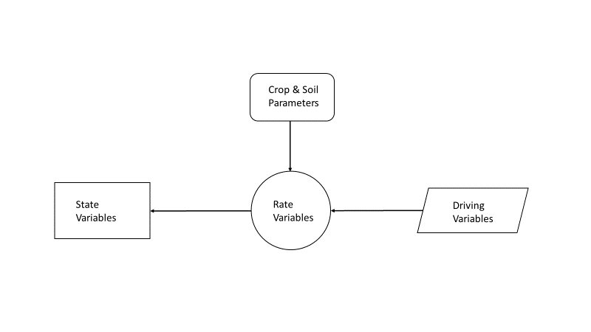

Arrows are used to represent inputs to and results from processes,

Models are not reality but can still be useful if done well.

**Chapter 2 Fundamental Guides in Constructing Crop Models**

The development of a model occurs in several steps including

* Definition of goals and objectives
* Preparations of assumptions (hypotheses)
* Mathematical formulation
* Programming
* Parameter estimation
* Model Evaluation

The definition of objectives should include:

1. What is the system to be modeled?
2. What are the major questions to be answered?
3. When does the modeling processes end?
4. How will the model output be analyzed, summarized and used?

A list of specific hypotheses should be developed by considering various factors including:

1. Models need to have sufficient generality to accomplish the objectives.
2. Hypotheses require input data as parameters and driving variables
3. The most useful models are those which have parameters and driving variables which can be measured or observed.
4. Existing models are a useful resource in the development of new models

There are a variety of programming language available. In this book, Visual Basic for Applications (VBA) in MS Excel is used because many students are familiar with Excel and can use Excel’s graphical capabilities instead of other more complicated programs.

**Chapter 3 Model Evaluation**

Transparency – model parameters, flow diagrams and code can be understood by others not involved in the development. The complexity depends on the modeling objectives and the assumptions and simplifications that acceptable. Modeling objectives may be heuristic (exploratory) or oriented to specific applications. Complexity needs to be sufficient to meet modeling objectives but not more complex as no benefits will really occur.

Robustness – model compares “favorably” with observations. The judgement of favorable depends on the modeling objectives. Prediction error results from structure and parameter errors. As model complexity increases structure error decreases as model more closely represents the real system but as complexity increases the number of equations and parameters representing the real system results in increasing parameter errors. There can also coding errors which can be difficult to detect and correct.

Statistical testing may show how well a model does in a particular situation but does not guarantee it will perform the same in different circumstances. It is important to remember there may be experimental and observation errors in the data to which the model is compared. Poor results may indicate a need to revisit the model assumptions and parameterization.

Model evaluation methods include graphical analysis comparing simulated with observed and residuals versus observations. Difference methods computing root mean square of deviations (RMSD) and correlation between simulated and observed data can be used along with regression.

**Chapter 4 Model Applications**

Achievement of the objectives of a crop model requires a proper understanding of the capabilities and limitations of the model. Models are limited because they cannot completely simulate the real world system. These limitations may be either structural or related to parameterization. Applications of crop models may be limited by the availability and quality of input data and parameter information. Therefore, it’s important that these considerations are addressed during the design stage.

Major applications of crop models include:

1. Research
   1. Integration of research knowledge obtained from independent studies of different processes and when little information is available.
   2. Cross disciplinary studies
   3. Developing needs for new experimental data collection
   4. Assessment of crop genetic improvements needs via parameter changes
   5. Identification of management practices to increase yields, reduce water consumption and environmental impacts from fertilizers.
   6. Assessment of yield potential across regions of variable climate and soil factors
   7. Climate change and variability assessments of yield and WUE.
   8. Environmental impacts and benefits of crop production
2. Crop Management
   1. Evaluating the effects of various management practices such as sowing and harvesting dates, planting density, irrigation and fertilization management, crop type and cultivar selection.
   2. Simulations of crop yields and optimal management practices in precision farming applications
   3. Forecasting crop yields
3. Education
   1. Crop models can be used to educate students and farmers

**Chapter 5 Status of Crop Modeling**

First crop models appeared in the 1960s. These models estimated light interception and photosynthesis in crop canopies. In the 1970s, crop modeling advanced to include stomatal conductance and maintenance respiration. The timeframe of modeling lengthened to include the entire growing season, crop phenology and partitioning by translocation of assimilates (sucrose, other saccharides and amino acids) to growing plant tissues. The complexity of the models such as GOSSYM, COTTAM and SOYGRO increased significantly and required many parameters some of which were difficult or impossible to measure because biological systems include many components over scales ranging from molecular to ecosystem. The representation of these complexities reduced the transparency of the crop models. Simpler models were found to produce better simulations of crop water stress and yields (Goudrian 1996).

In the 1980s and 1990s, modelers at Wageningen University developed a variety of crop models. These include ARID CROP, WOFOST, ORYZA and LINTUL. The Decision Support System for Agrotechnology Transfer (DSSAT) group has developed more than 15 different crop models to facilitate the evaluation and application of models that integrate information about climate, soils, crops and management. Recently, these models have been redesigned to facilitate the incorporation of new scientific advances along with databases needed for model development and verification. APSIM is a modular modeling framework developed in Australia. It consists of many different plant, soil and modules including diverse crops, pastures and trees; soil processes including water balance, nitrogen and phosphorus transformations, pH and erosion and a full range of management features. The CropSyst model developed at Washington State University includes features to simulate management of cropping systems, crop growth and yield, soil water, salinity and nitrogen budgets, residue production and decomposition at field to watershed scales. The SWAT model developed by the USDA is outgrowth of the earlier EPIC model. It simulates crop growth and yield using simple algorithms and has capabilities for field to watershed scale modeling.

**Chapter 6 Phenology – Temperature**

Modeling of phenology is simulating the time of occurrence of different plant developmental stages including emergence, flowering, maturity and senescence. Simulating crop development is important for management decisions such as pesticide, herbicide and fertilizer application and the timing of harvest. It can also be important in cultivar selection to optimize yield under different climatic conditions. In climate change studies, global warming will affect plant phenology resulting in changes growing season length, planting and harvest dates. Phenology is affected by multiple factors including temperature, photoperiod, drought and nutrition. Therefore, calendar dates are not a good predictor of phenological development.

The phyllochron index measures crop development as the number of visible leaves or nodes on the main plant stem. Developmental stages of a crop are described by standardized keys. The keys are reached when they are observed in 50% of the plants. The cumulative “temperature unit” (aka heat unit, thermal unit and thermal time) concept has been used extensively to quantify phenological development. The daily temperature unit is quantified as the difference between the mean daily temperature (Tmax – Tmin)/2 minus a basal temperature (Tb). By summing the daily heat units, the cumulative temperature units indicate the progress in the development from one stage to another. A limiting upper rate of accumulation may be imposed under high temperatures.

The basic thermal time model assumes the crop is not sensitive to photoperiod and drought, pests, weeds and nutrient deficiencies do not affect the development rate. The model described here is applicable to crops such as grains. Phenological stages to be simulated include:

1. Emergence – 50% of plants out of soil
2. Termination of leaf growth on the main stem (TLM)
3. Beginning of seed growth (BSG) – grains begin to grow (linear increase in harvest index)
4. Termination of seed growth – grains stop growing (harvest index stops increasing)
5. Harvest maturity – moisture content of grains decreases sufficiently for machine harvesting.

Phenological stage progression can be simulated using a 3-piece segmented linear function.

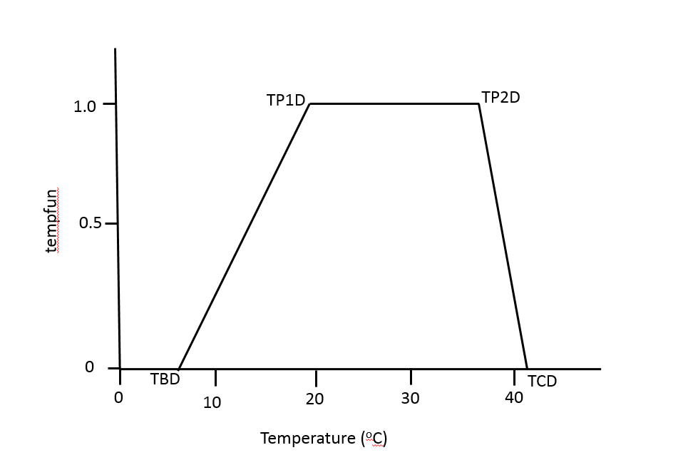

The rate of development is represented by the temperature response function (tempfun) which remains zero at mean daily temperatures (TMP) below the crop’s base temperature (TBD). Between TBD and the lower optimum temperature (TP1D), the rate of development increases linearly with increasing temperature. The rate of development continues to be maximum in the optimum range between TP1D and the upper optimum temperature (TP2D). At temperatures above TP2D but less than the ceiling temperature (TCD), the rate of development declines linearly. At temperatures above TCD, the rate of development is zero.

In pseudo code, the tempfun(TMP) can be expressed as:

If TMP ≤ TBD

tempfun = 0

Elseif TBD < TMP < TP1D

tempfun = (TMP – TBD) / (TP1D – TBD)

Elseif TP1D ≤ TMP ≤ TP2D

tempfun = 1

Elseif TP2D < TMD < TCD

tempfun = (TCD – TMP) / (TCD – TP2D)

Else

tempfun = 0

endif

These temperature parameters are referred to as cardinal temperatures and tend to be fairly stable within a species. Table 6.3 (pg 62) gives cardinal temperature values for some major crops.

The daily temperature unit (DTU) is calculated using the crop specific tempfun by assuming an optimal phenological growth rate (TP1D – TBD) and correcting for the actual growth using the tempfun.

DTU = (TP1D – TBD) * tempfun(TMP)

Note: TMP > TP1D but < TP2D does not result in any increased DTUs.

The phenological development up to the current day is obtained by summing the daily temperature units.

CTUi = CTUi-1 + DTU

This algorithm can be diagrammed as follows.

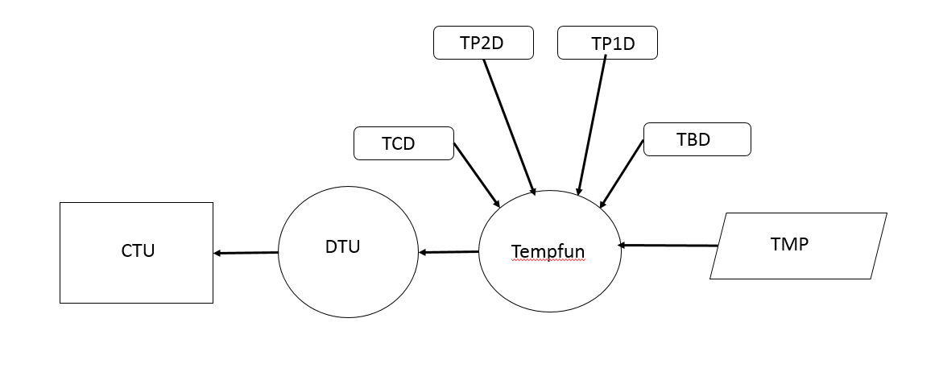where each phenological stage is defined in terms of CTUs. To estimate the transition from stage a to stage b, the CTU from a to b (CTUab) must be known.

The minimum number of days (CBDab) to complete the ab stage transition is CTUab divided by the maximum DTU per day (TP1D – TBD).

CBDab = CTUab / (TP1D – TBD).

For example, if it is known that the temperature units required for a wheat crop to grow from emergence to termination of leaf growth (tuEMERTLM) is 724 oC with TP1D of 25 oC and TBD of 0 oC. (See Table 6.4 pg 67)

CBDemertlm = 724 / (25 – 0) is a minimum of 29 days.

Temperature units between the phenological stages are experimentally determined for the following stages.

* Sowing (SOW) to emergence (EMR)
* EMR to termination of leaf growth on main stem (TLM)
* TLM to beginning of seed growth (BSG)
* BSG to termination of seed growth (TSG)
* TSG to harvest maturity (MAT).

Table 6.4 (pg 67) gives general temperature unit requirements for some major crops but indicates these values vary geographically.

Typically, daily time steps using Tmax and Tmin to calculate TMD is adequate for phenological stage simulations. However, when the TMD is near TBD or TCD, temperature units may differ depending on the time step size because daily temperatures do not reflect the range actual temperatures contributing to development either above or below the mean temperature during the day. Methods of predicting hourly temperatures have been developed (pg 71).

The pseudo code for the temperature based phenology follows.

**Phenology:**

**Note – variables that come from other modules are highlighted in yellow**

**Read Parameters**

TBD = base temperature (oC)

TP1D = lower optimum temperature (oC)

TP2D = upper optimum temperature (oC)

TCD = Ceiling temperature (oC)

tuSOWEMR = temperature units from sowing (SOW) to emergence EMR

tuEMRTLM = temperature units from EMR to termination of leaf growth on main stem (TLM)

tuTLMBSG = temperature units from TLM to beginning of seed growth (BSG)

tuBSGTSG = temperature units from BSG to termination of seed growth (TSG)

tuTSGMAT = temperature units from TSG to maturity (MAT)

**‘ Calculate total temperature units for each growth stage**

tuEMR = tuSOWEMR

tuTLM = tuEMR + tuEMRTLM

tuBSG = tuTLM + tuTLMBSG

tuTSG = tuBSG + tuBSGTSG

tuMAT = tuTSG + tuTSGMAT

**Initialize variables days after planting (DAP) and cumulative temperature units (CTU)**

DAP = 0: CTU = 0:

**'------------------------------- Temperature unit calculation**

If TMP <= TBD Or TMP >= TCD Then **Note – variable average daily temp (TMP) is computed in weather module.**

tempfun = 0

ElseIf TMP > TBD And TMP < TP1D Then

tempfun = (TMP - TBD) / (TP1D - TBD)

ElseIf TMP > TP2D And TMP < TCD Then

tempfun = (TCD - TMP) / (TCD - TP2D)

ElseIf TMP >= TP1D And TMP <= TP2D Then

tempfun = 1

End If

DTU = (TP1D - TBD) * tempfun (daily temperature units based on max temp units and tempfun)

CTU = CTU + DTU (cumulative temp units)

DAP = DAP + 1 (cumulative days after planting)

If CTU < tuEMR Then DTEMR = DAP + 1 'Saving days to EMR

If CTU < tuTLM Then DTTLM = DAP + 1 'Saving days to TLM

If CTU < tuBSG Then DTBSG = DAP + 1 'Saving days to BSG

If CTU < tuTSG Then DTTSG = DAP + 1 'Saving days to TSG

If CTU < tuMAT Then DTMAT = DAP + 1 'Saving days to MAT

If CTU > tuMAT Then MAT = 1 ‘End of crop simulation

Return

**Chapter 7 Phenology – Temperature and Photoperiod**

Day length is a function of latitude and day of the year. The inclusion of photoperiod in the phenology makes the model more applicable for crops which are sensitive to its effect across a wide range of locations. Some plants are not sensitive to photoperiod (day-neutral). Not all developmental stages are sensitive to photoperiod. For many plants, the developmental stage most sensitive to photoperiod is anthesis (flowering). In short-day plants, the rate of development decreases at day lengths longer than the “critical” photoperiod (CPP). In long-day plants, the rate of development accelerates by increasing day lengths up to the CPP.

For each phenological stage, there is a maximum rate of development (Rmax, fractional growth day-1) which occurs under optimal growth conditions. The minimum duration (Dmin, days) from the beginning to the end of a development stage is the reciprocal of Rmax.

There are several mathematical representations that have been used to represent the factors contributing to phenological stage development (R). The multiplicative model combines the tempfun function with a photoperiod function (ppfun).

R = Rmax * tempfun * ppfun

Correspondingly, R can be expressed as

R = tempfun * ppfun / Dmin

A development stage is complete when ∑R ≥ 1. Alternatively, development stages can be defined in terms of biological days BD where the product of the temperature unit and photoperiod functions defines how much of a BD occurs on a given day.

BDi = tempfun * ppfun

During a developmental stage, the biological days are accumulated (CBD).

CBDi = CBDi-1 + BDi

The developmental stage is complete when CBDi >= Dmin.

As discussed in the previous section, the biological days based on temperature units is similar. The minimum number of days (CBDab) to complete the ab stage transition is CTUab divided by the maximum DTU per day (TP1D – TBD).

CBDab = CTUab / (TP1D – TBD).

During stages when the plant is not sensitive to photoperiod ppfun = 1. The photoperiod length (PP, hrs) can be defined to include morning and evening twilight hours starting from when the sun is below the horizon (eg -6o) [see Box 7.2 pg 78 for code to calculate PP based on Keisling (1982)]. (Note: Appendix III has a list of variables and definitions used in the code)

For long-day plants, the photoperiod function (ppfun) is at its maximum when the PP exceeds the critical photoperiod length (CPP). In qualitative (aka obligatory) long-day plants, the minimum development rate below the base period (PPB=PPmin) is zero. In quantitative (aka facultative) long-day plants, the minimum development rate (ppfunmin) is non-zero. The development rate increases linearly with a slope of ppsen (the photoperiod sensitivity coefficient) such that the maximum rate is reached when PP=CPP. A composite 2-segment linear function can be used to simulate this effect. Mathematically, for long-day plants these relationships are expressed as:

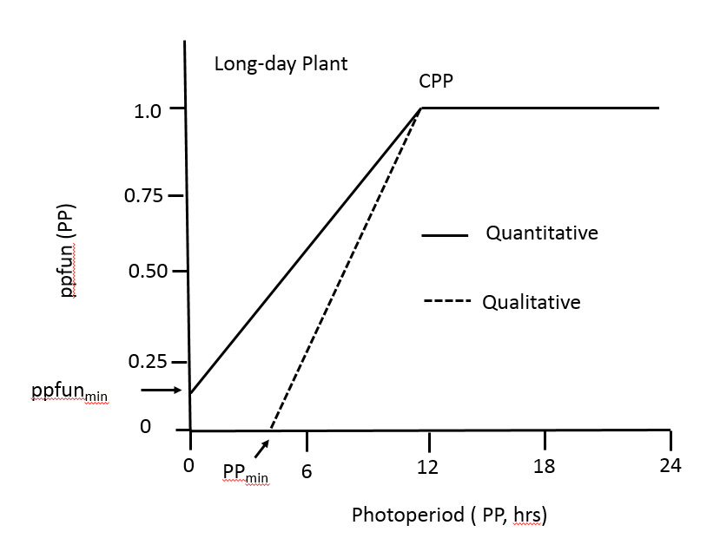

For quantitative long-day plants, the slope of ppfun is ppsen = (1 – ppfunmin) / CPP . Therefore, the y-intercept, ppfunmin = 1 – ppsen * CPP. Substituting into y = mx + b with m = ppsen, x = PP and b = ppfinmin = 1 – ppsen * CPP yields:

ppfun(PP) = ppsen * PP + (1 – ppsen * CPP)

Rearranging terms yields

ppfun(PP) = 1 – ppsen * (CPP – PP)

Pseudo code for quantitative long-day plants is the following.

If PP < CPP then

ppfun = 1 – ppsen * (CPP – PP)

else

ppfun = 1

endif

It is important to note that specifying the parameters ppsen and CPP determines the value of ppfunmin.

For qualitative long-day plants, ppsen = (1 – 0) / (CPP – PPmin). Solving for PPmin = CCP – 1/ppsen. Now ppsen also = (0 – b) / (PPmin – 0). Solving for y-intercept b = - ppsen * PPmin. Substituting into y = mx + b yields

ppfun = ppsen * PP – ppsen * PPmin; substituting for PPmin yields

ppfun = ppsen * PP – ppsen (CCP – 1/ppsen) and rearranging yields

ppfun = 1 - ppsen * (CPP – PP)

The pseudo code for the qualitative long- day plant is similar,

If PP ≤ PPmin then

ppfun = 0

elseif PP < CPP

ppfun = 1 – ppsen * (CPP – PP)

else

ppfun = 1

endif

It is important to note that specifying the parameters ppsen and CPP determines the value of PPmin.

In short-day plants, CPP is the PP above which the rate of development starts to decline from the maximum rate.

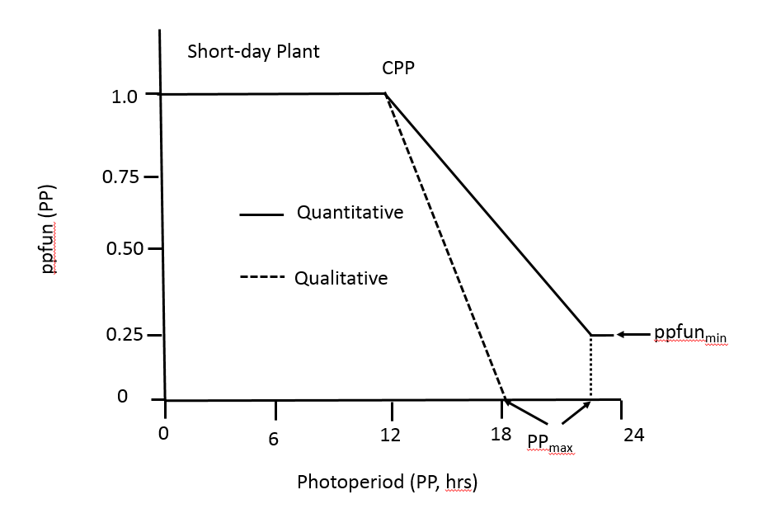

For quantitative short-day plants, the slope of the decreasing segment is ppsen = (ppfunmin - 1) / (PPmax - CPP). Solving for ppfunmin = 1 + ppsen* (PPmax – CPP). Another expression for the slope is ppsen = (b – 1) /(0 –CPP) where b is the y-intercept of the equation of a straight line y = mx + b. Solving for b = 1 – ppsen * CPP. Substituting into the equation y = mx + b yields:

ppfun = (ppfunmin - 1) / (PPmax - CPP) * PP + (1 – ppsen * CPP). Substituting for ppfunmin yields:

ppfun = (1 + ppsen* (PPmax – CPP) -1) / (PPmax - CPP) * PP + (1 – ppsen * CPP). Simplifying yields:

ppfun = 1 + ppsen * (PP – CPP).

In the derivation above ppsen is the slope of the decreasing segment of the ppfun. This means that ppsen would have a negative value. In practice, ppsen is a parameter whose value is considered to be positive. Therefore, it is necessary to modify the equation for ppfun by changing the sign of the second term in order to account for this convention which yields the following:

ppfun = 1 - ppsen * (PP – CPP).

The pseudo code for the quantitative short-day plants is given by:

If PP ≤ CPP then

ppfun = 1

elseif CCP < PP < PPmax

ppfun = 1 - ppsen * (PP – CPP)

else

ppfun = 1 - ppsen * (PPmax – CPP) [Note: this is the expression for ppfunmin , see above]

endif

In this case, there are not a unique expressions for either PPmax or ppfunmin . They are defined in terms of each other by ppfunmin = 1 + ppsen* (PPmax – CPP). To model this case requires specifying the three parameters ppsen, CPP and PPmax.

For qualitative short-day plants, the same approach can be used to derive the ppfun equation by setting ppfunmin = 0. The resulting equation is ppfun = 1 - ppsen * (PP – CPP). The pseudo code for qualitative short-day plants is the following.

If PP ≤ CPP then

ppfun = 1

elseif CPP < PP < PPmax

ppfun = 1 - ppsen * (PP – CPP)

else

ppfun = 0

endif

In this case, PPmax is uniquely defined by PPmax = (CPP * ppsen – 1)/ ppsen.

In neutral-day plants, ppfun = 1.

The required parameters for modeling phenological development as a function of both temperature and photoperiod with the multi-segment functions described above include:

* Cardinal temperatures – TBD, TP1D, TP2D & TCD
* Critical photoperiod – CPP
* Photoperiod sensitivity – ppsen
* Biological day requirements when plant sensitivity to photoperiod begins (bdBRP) and ends (bdTRP)
* Biological day requirements of each development stage – BDab or CBDab

The combined method is diagramed below.

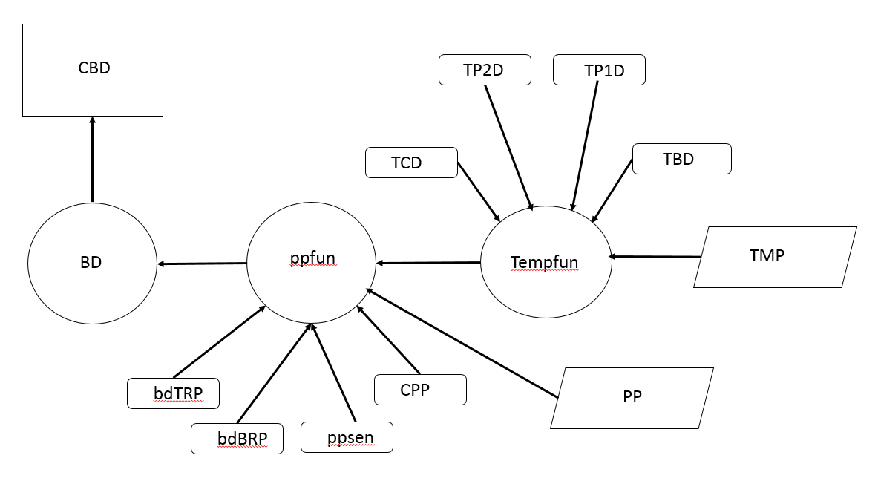

Within a species, CPP is relatively constant with the photoperiod sensitivity parameter, ppsen, characterizing cultivar differences (see Table 7.2 pg 82). Controlled-environment determination of the photoperiod parameter is not always available. Therefore, some software programs such as SIMPLEX and DEVEL have been developed to estimate photoperiod and temperature function parameters (see Soltani et al (2006b). Table 7.3 pg 86 provides parameters for some example crops.

**Chapter 8 Phenology - Vernalization**

For some plants, exposure to cold temperatures (vernalization) determines the rate of development prior to flowering. Vernalization is usually seen in crops like wheat and rapeseed (canola). Vernalization typically takes place when the daily mean temperature (TMP) is between -5 and 16 oC with the maximum effect between 0 and 8 oC. In plants that are sensitive to vernalization, the growing point is often located in the soil. Therefore, the soil surface temperature of crown temperature (Tcr) should be used in the calculation of vernalization. The following equation can be used.

Tcr = 2 + Ta * (0.4 + 18 * (Ds – 0.15)2 )

Where Ds is the snow depth in meters (m). If Ds > 0.15 m then Ds = 0.15. The Tcr is computed with Tmin and Tmax separely and the values are averaged to obtain Tcr. If snow depth is not known, precipitation is assumed to be snow when

If Tmax ≤ 1 oC then

Dsi (mm) = Dsi-1 + 10 * precip (mm)

Elseif Dsi-1 > 0

Dsi = Dsi-1 – (10 * Tmax + 4 * precip)

If Dsi < 0 then

Dsi = 0

endif

endif

Note: In the spreadsheet model precipitation (RAIN) is in units of mm while Dsi (SNOW) is in units of cm so the actual code used is different.

Vernalization results from the cumulative exposure of the plant to below the ceiling temperature (TCV) and above the base temperature (TBV). Consequently, the vernalization day (VERDAY) is calculated on each day of the calendar year using a 3-segment linear function as diagrammed below.

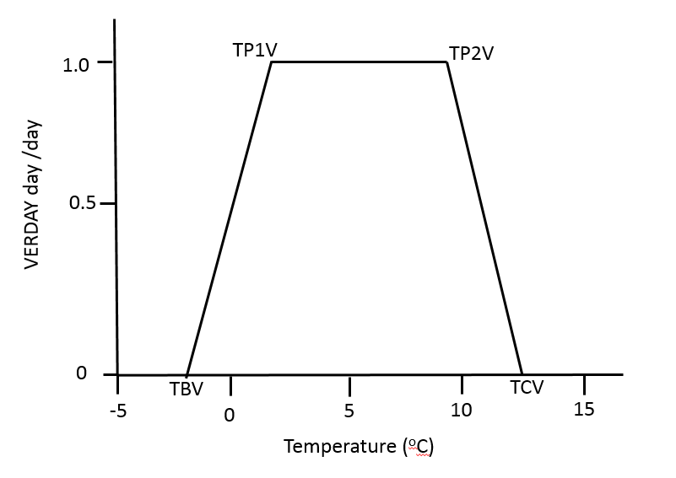

Where TP1V and TP2V are the cardinal vernalization temperatures between which VERDAY equals its maximum value of 1. During a sensitive development stage, Tmax > 30 oC. may result in de-vernalization if CUMVERi < 10.

The algorithm for its calculation can be expressed as:

If TMP ≤ TBV then

VERDAY = 0

Elseif TBV < TMP < TP1V

VERDAY = (TMP – TBV) / (TP1V – TBV)

Elseif TP1V ≤ TMP ≤ TP2V

VERDAY = 1

Elseif TP2V < TMP < TCV

VERDAY = (TCV – TMP) / (TCV – TP2V)

Elseif TMP ≥ TCV

VERDAY = 0

Endif

The cumulative sum of vernalization days CUMVER during the development stages is obtained summing the daily values. High temperatures during a sensitive period may result in de-vernalization if CUMVERi < 10 and Tmax > 30 oC, then the CUMVER is reduced by 0.5 day for each degree over 30 oC. Thus, the algorithm is expressed as:

If CUMVERi < 10 and Tmax > 30 oC then

CUMVERi = CUMVERi-1 – 0.5 * (Tmax -30)

Else

CUMVERi = CUMVERi-1 + VERDAY

endif

The vernalization function, vernfun, is a function of the cumulative vernalization days (CUMVER), the days required to reach maximum vernalization (VDSAT) and the sensitivity of the development rate to vernalization (vsen). This is shown on the diagram below.

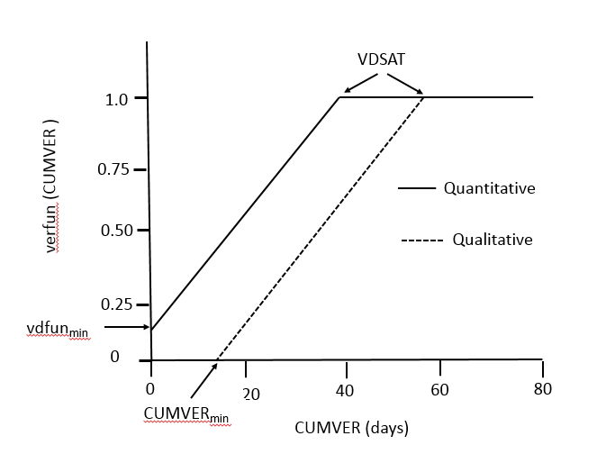

For quantitative plants, the slope of verfun is vsen = (1 – vpfunmin) / VDSAT . Therefore, the y-intercept, b = vpfunmin = 1 – vsen * VDSAT. Substituting into y = mx + b with m = vsen, x = CUMVERi and b = 1 – vsen * CPP yields:

verfun (CUMVERi) = vsen * CUMVERi + (1 – vsen * VDSAT)

Rearranging terms yields

verfun (CUMVERi) = 1 – vsen * (VDSAT – CUMVERi )

The pseudo code for quantitative function is:

If CUMVERi < VDSAT then

verfun (CUMVERi) = 1 – vsen * (VDSAT – CUMVERi )

else

verfun (CUMVERi) = 1

endif

In this case, specifying vsen and VDSAT defines vpfunmin. (See highlighted equation above)

For qualitative plants, the slope, vsen = 1 / (VDSAT – CUMVERmin ). This expression can be solved for CUMVERmin = (VDSAT *vsen -1) /vsen. vsen can also be expressed as in terms of the y-intercept b as (0 – b) / (CIMVERmin – 0) which simplifies to vsen = - b / CUMVERmin. Solving for b = - vsen * CUMVERmin. Substituting into y = mx + b yields:

vdfun( CUMVERi) = vsen * (CUMVERi) – vsen * CUMVERmin

substituting for CUMVERmin yields:

vdfun( CUMVERi) = vsen * (CUMVERi) – vsen *( VDSAT *vsen – 1) /vsen

which simplifies to:

vdfun( CUMVERi) = 1 - vsen * (VDSAT - CUMVERi)

The pseudo code for the qualitative plants function is

If CUMVERi ≤ CUMVERmin

vdfun( CUMVERi) = 0

Elseif CUMVERmin < CUMVERi < VDSAT

vdfun( CUMVERi) = 1 - vsen * (VDSAT - CUMVERi)

else

vdfun( CUMVERi) = 1

endif

In this case, CUMVERmin is uniquely defined by VDSAT and vsen. (See highlighted equation above)

The effect of the vernalization on the calculation of biological days (BD) can be simulated as follows:

BD = tempfun * ppfun * verfun

where verfun has values between 0 and 1. In development stages where the plant is not sensitive to vernalization, verfun = 1.

The required parameters for modeling phenological development as a function of temperature, photoperiod and vernalization with the multi-segment functions described above include:

* Cardinal temperatures – TBD, TP1D, TP2D & TCD
* Critical photoperiod – CPP
* Photoperiod sensitivity – ppsen
* Biological day requirements when plant sensitivity to photoperiod begins (bdBRP) and ends (bdTRP)
* Biological day requirements of each development stage – BDab or CBDab
* Vernalization temperatures - TBV, TP1V, TP2V & TCV
* Vernalization saturation days – VDSAT
* Vernalization sensitivity - vsen

The combined method is diagramed below.

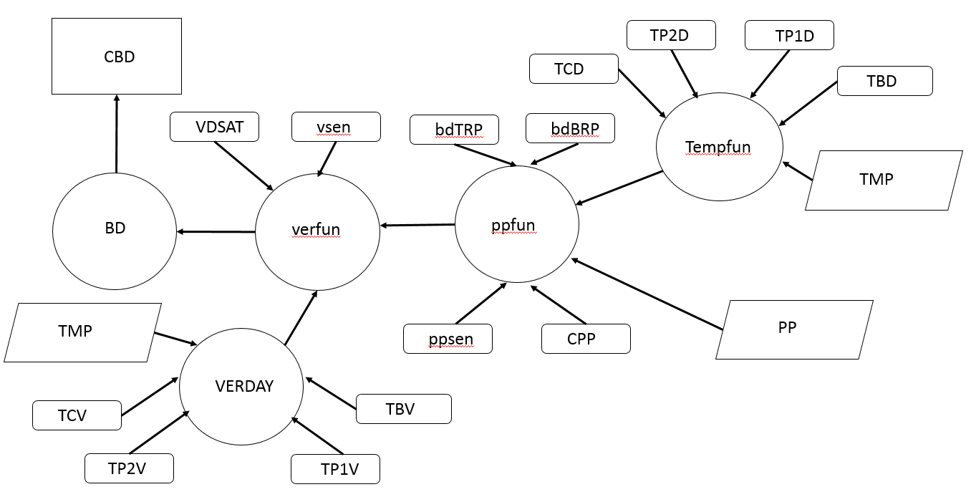

**Chapter 9 Crop Leaf Area**

Crop leaf area is an important determinant of crop yield and water use. There are three basic approaches of simulating crop leaf area development including carbon based methods, temperature based methods and hybrid methods. The carbon based methods assume that the rate of increase in plant leaf area depends on the amount of dry matter available for leaf growth on a daily basis. The leaf area is computed as the amount of dry matter portioned for leaf growth times the specific leaf area. In contrast temperature based methods assume leaf development is not generally limited by the availability of assimilates but depends on linking leaf area to temperature. The hybrid methods assume solar radiation determines the amount of photosynthate available and temperature determines the rate of cell division and expansion.

Leaf area development is divided into four stages.

**From sowing (SOW) to emergence (EMR)**

No leaf development

**From EMR to termination of leaf growth on the main stem (TLM)**

Calculate the daily thermal unit (DTU oC) where DTU = (Tmax + Tmin)/2 – TBD (basal temperature oC)

Calculate the daily increase in leaf nodes (INODE) equal to DTU/PHYL (phyllochron oC per leaf/node). Note: the input parameter PHYL is the reciprocal of the slope of the line of cumulative number of leaves on main stem (MSNN) versus cumulative DTU. See Figure 9.1 on pg 105.

Calculate INODE where INODE = DTU/PHYL

Calculate MSNN where MSNNi = MSNNi-1 + INODE

The relationship between plant leaf area (PLA, cm2 per plant) and MSNN is expressed as a power function where PLA = PLACON*MSNNPLAPOW . Assuming that PLA = 1 cm2 when MSNN = 1 simplifies this equation to PLA = MSNNPLAPOW . PLAPOW is a function of plant density (PDEN, plants m-2) given by PLAPOW = -0.0044 * PDEN + 2.29 (See pg 106).

Calculate the PLAi = MSNNiPLAPOW

Calculate daily increase in crop LAI (GLAI, m2 m-2 day-1) where GLAIi = (PLAi – PLAIi-1) * PDEN / 10,000

The factor 10,000 is (10000 cm2 per m2) is needed to convert PLA from cm2 per plant to m2 per plant.

The diagram for these calculations is the following:

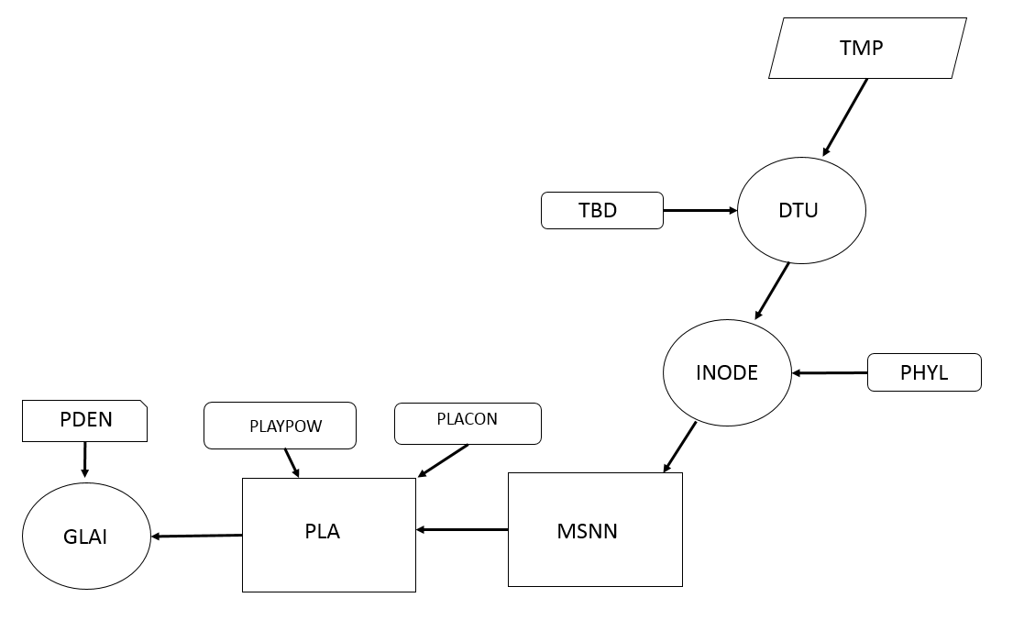

**From TLM to beginning of seed growth (BSG)**

Calculate the GLAI from the available dry matter for leaf growth (GLF g m-2 day-1) and the specific leaf area (SLA m2 g-1) where GLAI = GLF * SLA. The daily increase in leaf dry matter, GLF, is covered in Chapter 11.

Diagrammatically this is represented as:

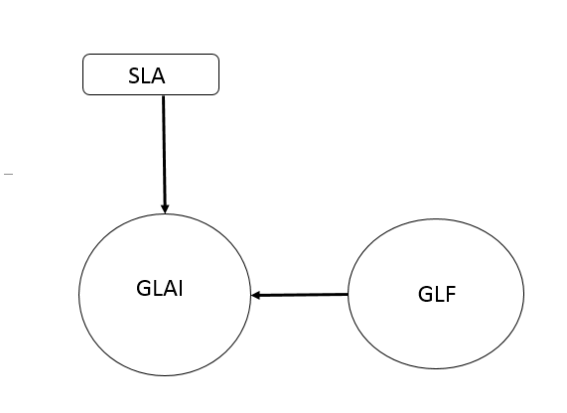

**Leaf area after BSG**

In many crops, leaf senescence is mainly affected by the growth of seed during which nitrogen is mobilized from the leaves to the seeds. This is discussed in Chapter 17. In the simple model presented here, leaf senescence is modeled as a linear decrease in LAI during seed growth, reaching 0 at maturity. The daily decrease in LAI (DLAI m2 m-2 day-1) is a function of the temperature units at maturity (tuMAT) and the BSG (tuBSG), LAI at the BSG (BSGLAI) and daily thermal units (DTU).

DLAI = BSGLAI * DTU / (tuMAT – tuBSG)

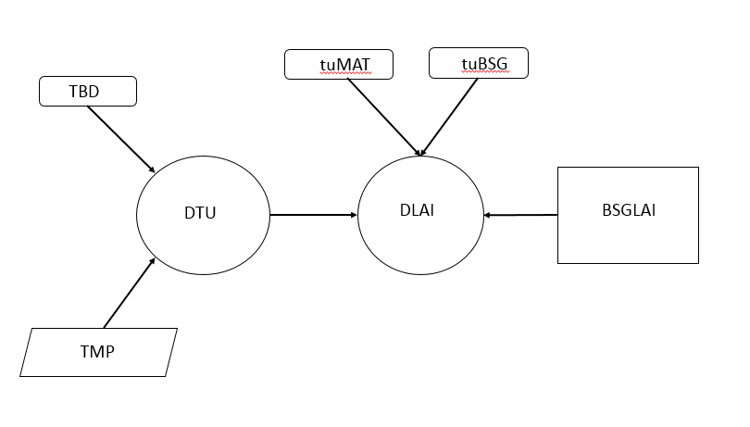

The current crop LAI can be calculated by

LAIi = LAIi-1 + GLAI – DLAI

In some cases, the PHYL parameter may not be constant. Therefore, the PHYL may need to be changed after a certain amount CTU. Another problem may be the SLA is not constant. This change in SLA may be related solar radiation and temperature. See Figure 9.9 on pg 114. Shading and freezing may also reduce the LAI. See discussions at end of Chapter 9.

The pseudo code for Crop LA without N effects:

(Note: Parameters and variables coming from other modules are highlighted in yellow.)

**Read crop parameters**

PHYL (oC per leaf)

PLACON (constant multiplier for eqn relating LAI to main stem node number)

PLAPOW (power coefficient for eqn relating LAI to main stem node number)

SLA (specific leaf area m2 g-1)

**Initialize variables**

MSNN = 1 (Initial node #)

PLA2 = 0 (plant leaf area today, cm2 per plant)

PLA1 = 0 (plant leaf area yesterday, cm2 per plant)

LAI = 0 (leaf area index, m2 leaves per m2 ground surface)

MXLAI = 0 (Max leaf area, m2 m-2)

WSFL = 1 (water stress factor for leaf development (see pg 196), computed in the soil water module is constant in the potential production model (PPM))

**'------------------------------- Yesterday LAI to intercept PAR today**

LAI = LAI + GLAI – DLAI (Calculate cumulative LAI)

If LAI < 0 Then LAI = 0

If LAI > MXLAI Then MXLAI = LAI **'Saving maximum LAI**

**'------------------------------- Daily increase and decrease in LAI today**

If CTU <= tuEMR Then (No Leaf development or senescence before EMR)

GLAI = 0: DLAI = 0

ElseIf CTU > tuEMR And CTU <= tuTLM Then **(Vegetative growth stage)**

INODE = DTU / PHYL (daily increase in node number, # day-1)

MSNN = MSNN + INODE (total # of nodes)

PLA2 = PLACON * MSNN ^ PLAPOW (total plant LAI today)

GLAI = ((PLA2 - PLA1) * PDEN / 10000) * WSFL (Daily increase in LAI) Note – PDEN (m2 per plant) is a management parameter. WSFL is a water stress factor affecting LAI increase.

PLA1 = PLA2 (Update yesterday’s plant leaf area)

DLAI = 0 (No senescence)

ElseIf CTU > tuTLM And CTU <= tuBSG Then **(Transition stage before BSG)**

GLAI = GLF * SLA (Daily increase in leaf weight, GLF, is calculated in Dry Matter production module)

BSGLAI = LAI **'Saving LAI at BSG**

DLAI = 0 (No senescence)

ElseIf CTU > tuBSG Then **(Grain filling stage)**

GLAI = 0 (No leaf growth)

DLAI = DTU / (tuMAT - tuBSG) * BSGLAI (Senescence based on today temperature units)

End If

**Chapter 10 Dry Matter Production**

Several methods are commonly used to simulate dry matter production (DMP). In some models such as the Wageningen and CROPGRO models, are based on detailed modeling of photosynthesis, growth and maintenance respiration. Radiation intercepted by the leaves is calculated first, then gross photosynthesis, and finally dry matter after subtraction of maintenance and growth respiration from gross photosynthesis. Other models simulate dry matter production based on the concept of radiation interception and radiation use efficiency (RUE, g MJ-1). Photosynthetically active radiation is about 48 % of the total solar radiation (SRAD).

PAR = 0.48 * SRAD

To calculate DMP it is necessary to determine the amount of PAR that is intercepted by the canopy. The fraction of intercepted PAR (FINT) is a function of the extinction coefficient (KPAR) and the LAI. KPAR can vary with respect to leaf angle and time of day. There are a variety of methods to estimate KPAR. In this model, KPAR is assumed to be constant throughout the crop life cycle. (See Figure 10.5 pg 121)

FINT = 1 – exp(-KPAR * LAI)

RUE is a summary variable that represents the processes of photosynthesis, maintenance and growth respiration. In this chapter, RUE is defined in terms of above ground crop dry matter. Each crop is represented by a unique potential RUE (IRUE, g MJ-1) reflecting its maximum photosynthetic capacity and biochemical composition of dry matter produced. In general, C4 plants have a higher RUE than C3 species. Typically, plants producing mainly carbohydrates have higher RUE than plants producing proteins and lipids (See Table 1.1 pg 3). RUE can be determined from the slope of the plot of the cumulative dry matter production versus the cumulative intercepted PAR (See Figure 10.4 pg 122).

Several factors can affect the potential RUE including temperature, water and CO2 concentration. A three segment linear function can be used to represent the temperature effect. (see Figure 10.6 pg 122)

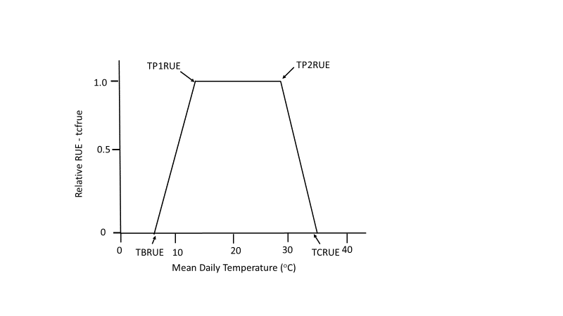

In pseudo code, this temperature correction factor (tcfrue) is expressed as:

**----------------------------------------------Adjustment of RUE**

If TMP ≤ TBRUE then

tcfrue = 0

Elseif TBRUE < TMP < TP1RUE

tcfrue = (TMP – TBRUE) / (TP1RUE – TBRUE)

Elseif TP1RUE ≤ TMP ≤ TP2RUE

tcfrue = 1

Elseif TP2V < TMP < TCRUE

tcfrue = (TCRUE – TMP) / (TCRUE – TP2RUE)

Elseif TMP ≥ TCRUE

tcfrue = 0

Endif

Table 10.1 (pg 125) has parameter values for use in the tcfrue function.

The corrected RUE (RUEo) is computed by multiplying the radiation use efficiency under optimal conditions (IRUE, g MJ-1) by the tcfrue correction factor.

RUE = IRUE * tcfrue

Note: RUE may also be corrected for CO2 concentration (µmol mol-1) by the following equation:

RUE = RUE * ( 1 + b * Ln( CO2 / Co )

Where Co is the reference CO2 concentration of 350 µmol mol-1 and the parameter b = 0.4 in C4 plants and 0.8 in C3 plants (Penning De Vries et al, 1989).

RUE can also be affected by seed formation in some oil crops (see Chapter 11) and changes in leaf nitrogen concentration during seed formation (see Chapter 17).

**--------------------------------------------- Daily Dry Matter Production**

The change in the daily amount of dry matter produced (DDMP) is calculated by:

PAR = 0.48 * SRAD

FINT = 1 – exp(-KPAR * LAI)

DDMP = PAR * FINT * RUE

The above ground accumulated dry matter (WTOP, g m-2) is calculated by adding DDMP to the previous days WTOP.

WTOPi = WTOPi-1 + DDMP

The flowchart for this process is as follows:

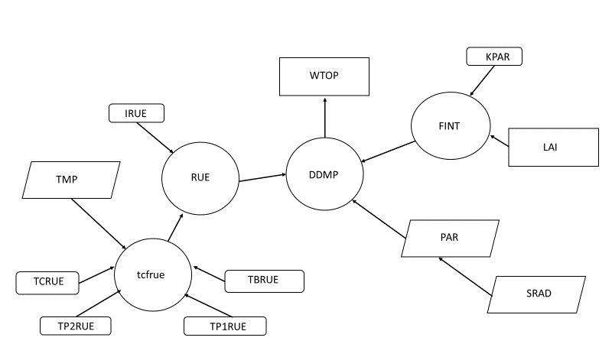

**Chapter 11 Dry Matter Distribution and Yield**

Dry matter distribution has been simulated by a variety of methods. In the simplest case, the distribution of dry matter between grain and non-grain organs is based on the concept of the harvest index (HI) which is the ratio of the grain mass to the non-grain organs. In more complex methods, the distribution of dry matter into each organ is based on organ specific partitioning coefficients. Additional considerations in calculating yield formation is the relationship between the supply of assimilates and the demand from the grains. In the source limited approach, grain growth and yield is only limited by the capacity of the leaves and other organs to provide assimilates to the grains. In sink-limited approaches, it is assumed that assimilate production is sufficient and grain growth is limited by the ability of these sinks to absorb assimilates. In combined approaches, the production of assimilates and the demands are calculated separately and the minimum value is used.

In this model, specific sinks for assimilates are specified in each phenological stage. Three sinks are considered, leaves, stems and grains or other storage organs. The stems include the actual stems as well as any other non-leaf or grain components such as seed bearing pods or rachises.

**Phenological Stage** **Active Sinks**

Sowing to emergence None

Emergence to TLM Leaves, stems

TLM to BSG Leaves, stems

BSG to TSG Grain

TSG to maturity None

The daily increase in leaf mass (GLF, g m-2 day-1) is simulated as a function of the daily crop growth (DDMP, g m-2 day-1) multiplied by the partitioning fraction of the daily leaf growth (FLF, g g-1). Daily mass production not used by the leaves is deposited in the stems (GST, g m-2 day-1).

From emergence to TLM, there are 2 phases. In the first phase, a higher portion (FLF1A) of DDMP is partitioned into the leaves at low total above ground plant mass, WTOP. In the second phase, less DDMP is portioned into the leaves as WTOP continues to increase above WTOPL. This fraction is FLF1B. (See Figure 11.1 pg 133).

If WTOP < WTOPL then

GLF = DDMP * FLF1A

Else

GLF = DDMP * FLF1B

endif

GST = DDMP – GLF

The accumulated leaf dry matter (WLF, g m-2) is obtained by summing GLF with the previous days WLF.

WLFi = WLFi-1 + GLF

Similarly, the cumulative stem weight is obtained by summing GST with WST from the previous day.

WSTi = WSTi-1 + GST

From TLM to BSG, FLF2, is the partitioning coefficient. Typically, FLF1A & FLF1B > FLF2 because more growth is occurring in the leaves from emergence to TLM than occurs from TLM to BSG.

GLF = DDMP * FLF2

GST = DDMP – GLF

From BSG to TSG, it is assumed there is no further leaf growth. In this phase, two sources of assimilates are available for grain growth. The first is daily dry matter production, (DDMP). The second is translocation from other vegetative organs (TRLDM, g m-2). The total amount of translocated dry matter TRLDM is calculated as a fraction (FRTRL, g g-1) of the total crop mass present at BSG (BSGDM, g m-2).

TRLDM = BSGDM * FRTRL

During grain filling, a portion of TRLDM is transported to the grains each day. The rate of the transfer (TRANSL, g m-2 day-1) is proportional to the daily temperature unit, DTU, divided by the total amount of thermal units in the grain filling period (tuTSG – tuBSG). Therefore, by the end of the grain filling period (TSG) all of the TRLDM will have been translocated to the grains. The amount of daily transfer is given by:

TRANSL = TRLDM * DTU / (tuTSG – tuBSG)

To calculate the daily seed growth (SGR, g m-2 day-1) it is also necessary to account for differences in the energy content per unit mass of the vegetative and grain dry matter. This difference is simulated by a grain conversion coefficient (GCC, g g-1) which is less than 1 when high protein and lipid content grains are produced. The combined equation for daily grain growth is:

SGR = (DDMP + TRANSL) * GCC

The cumulative grain dry weight (WGRN, g) is obtained by adding DSGR to the previous days WGRN.

WGRNi = WGRNi-1 + SGR

The pseudo code for these processes is as follows:

**--------------------------------------------------------Biomass portioning and yield formation**

If CTU <= tuEMR

DDMP=0, GLF=0, GST=0, TRANSL=0, SGR=0

Elseif CTU > tuEMR And CTU <= tuTLM

If WTOP < WTOPL then

GLF = DDMP * FLF1A

Else

GLF = DDMP * FLF1B

Endif

GST = DDMP – GLF

SGR = 0

Elseif CTU > tuTLM And CTU <= tuBSG

GLF = DDMP * FLF2

GST = DDMP – GLF

SGR = 0

BSGDM = WTOP ‘Saving WTOP at BSG

The relational diagram is presented as a flow chart below:

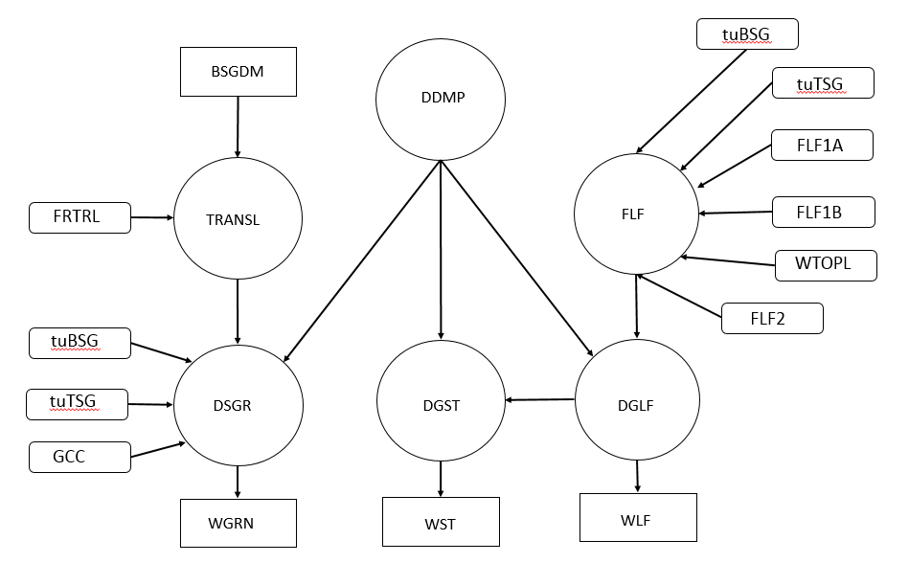

Parameter values relating to dry matter and grain production are presented in Table 11.2 pg 134.

In the preceding method, the remobilization fraction of the BSCDM, FRTRL is a constant throughout the grain filling period from BSG to TSG. In some cases, the FRTRL is adjusted for crop mass at the BSG to reflect conditions experienced by the crop up to BSG. (See Figure 11.3 pg 139).

**Chapter 12 A Model for Potential Production**

The potential production model (PPM) includes daily calculation of the crop phenology, LAI, dry matter production and distribution. A flow chart of the PPM model presented below.

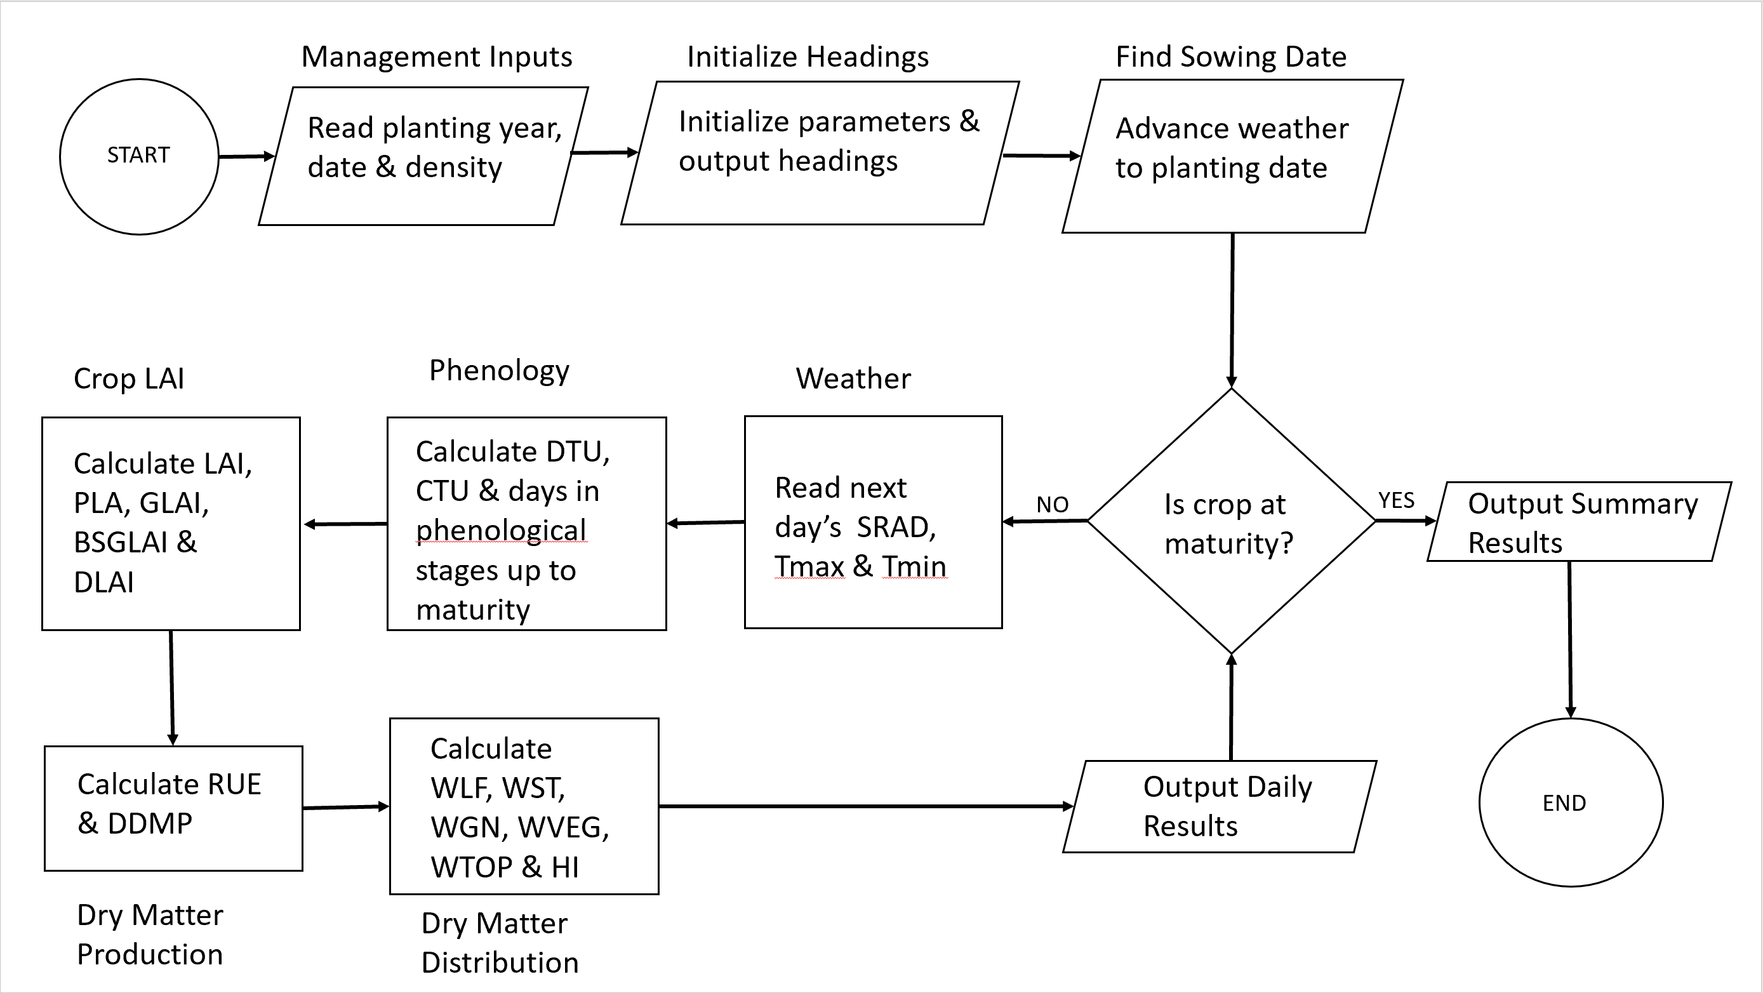

The PPM program only includes the effects of temperature and solar radiation on crop growth and production. Photoperiod and vernalization effects are not included in the PPM model. In the following discussion, input files, modules, parameters, functions and initialized variables are in bold type. Inputs from other modules are highlighted in yellow.

The **Main Program** is a loop which calls the sequence of modules. The **Management module** reads the planting year (**pyear**), planting day of the year (**pdoy**) and the planting density (**PDEN**, # m-2) from the **Run input** sheet. The **Initialize Headers module** sets the values that control the initial input readings for each of the submodules and sets crop maturity (**MAT= 0**). This module also writes headers for each of the variables included in the **Daily Output** work sheet.

Next, the **Find Sowing Date module** reads the **Weather** **module** input data until it finds starting year (pyear) and planting day of the year (pdoy). This loop starts with the Weather module and continues until the crop is mature (**MAT = 1**).

The weather data is an array which contains the following daily data. The first two columns are the year (**YEAR**) and day of the year (**DOY**) in Julian days. The solar radiation (**SRAD**) has units of mega Julies (MJ). The maximum (**TMAX**) and minimum (**TMIN**) temperatures have units of centigrade (oC), the precipitation (**RAIN**) is in units of millimeters (mm). The mean daily temperature (**TMP**) is calculated as the average of TMAX & TMIN. Precipitation is not a variable in the PPM.

In the following description of each of the modules, variables which are outside of the particular module are highlighted in yellow (eg TMP is calculated in the Weather Module but used in other modules.)

The **Phenology module** is called next. The first time the module is called data are read (**iniPheno = 0**) from the **Crop file**. The **tempfun** parameters are read including the basal temperature **(TBD**), the optimal temperatures (**TP1D & TP2D**) and the ceiling temperature (**TCD**). The temperature unit change associated with each of the phenological stages are read including **tuSOWEMR, tuEMRTLM, tuTLMBSG, tuBSGTSG** and **tuTSGMAT**. These parameters are used to compute the total temperature units at the end of each of the stages as follows:

tuEMR = tuSOWEMR

tuTLM = tuEMR + tuEMRTLM

tuBSG = tuTLM + tuTLMBSG

tuTSG = tuBSG + tuBSGTSG

tuMAT = tuTSG + tuTSGMAT

The days after planting (**DAP**) and the cumulative temperature units (**CTU)** are initialized to 0. There is also a water stress factor (**WSFD**), for low soil moisture growth which would be included if the **SoilWater module** is used. In the PPM, WSFD is initialized equal to 1 and **iniPheno** is set equal to 1. (Note: In Visual Basic code in which the PPM is written, an initially undeclared variable like iniPheno is by default equal to 0.)

Next, the value of the temperature unit function (**tempfun**) is obtained (see graph in Chapter 6) based on the mean daily temperature (TMP) and the daily temperature unit (DTU) is computed.

DTU = (TP1D – TBD) * tempfun(TMP)

The cumulative temperature units up to the current day is obtained by summing the daily temperature units with the previous day (CTUi-1).

CTUi = CTUi-1 + DTU

and the days after planting (DAP) is determined by incrementing.

DAP = DAP + 1.

Next the number of days after planting to reach the end of each of the phenological stages is determined from the CTUi using and if – then structure where STAGE = EMR, TLM, BSG, TSG & MAT.

If CTU < tuSTAGE then DTSTAGE = DAP +1

Finally, when CTU > tuMAT then MAT is set to 1 which will terminate the loop and result in the printing of the **Summary output** file.

The **Crop LAI module** is called next. If this module has not been called before (iniLAI = 0, See preceding note regarding Visual Basic), it reads from the Crop file the phyllochron (PHYL, oC per leaf node), the parameters (PLACON & PLAPOW) and the specific leaf area (SLA, m2 g-1). It also initializes the main stem node number (MSNN =1), leaf area index (LAI = 0), the yesterday’s and today’s plant leaf areas (PLA1 & PLA2 =0), the maximum leaf area (MXLAI=0) and sets iniLAI equal to 1 so that the LAI input parameters are not read in subsequent iterations.

After initialization is complete, the yesterday’s LAI to intercept photosynthetically active radiation (PAR) is updated by adding yesterday’s increase in leaf area (GLAI, m2 m-2 day-1), subtracting the leaf senescence (DLAI, m2 m-2 day-1) from the previous LAI.

LAI = LAI + GLAI – DLAI

If LAI > MXLAI then MXLAI = LAI. Saves the larger LAI.

(Note: In the initial loop, GLAI and DLAI = 0 because of the Visual Basic code)

Next the daily increase in GLAI is calculated based on the phenological stages.

If CTU <= tuEMR Then (No leaf growth prior to emergence)

GLAI = 0: DLAI = 0

ElseIf CTU > tuEMR And CTU <= tuTLM Then (Between emergence and termination of leaf growth on the main stem)

INODE = DTU / PHYL (Increment of nodal growth)

MSNN = MSNN + INODE (Updated node number)

PLA2 = PLACON * MSNN ^ PLAPOW (Today’s plant leaf area)

GLAI = ((PLA2 - PLA1) * PDEN / 10000) (Daily increase in LAI)

PLA1 = PLA2 (Save today’s PLA for tomorrow’s calculation)

DLAI = 0 (No senescence in this stage)

ElseIf CTU > tuTLM And CTU <= tuBSG Then (Between termination of growth on the main stem and beginning of seed growth)

GLAI = GLF * SLA (GLF (g m-2 day-1) is the daily increase in leaf dry matter)

BSGLAI = LAI 'Saving LAI at beginning of seed growth (BSG)

DLAI = 0 (No senescence in this stage)

ElseIf CTU > tuBSG Then

GLAI = 0 (No leaf growth after BSG)

DLAI = DTU / (tuMAT - tuBSG) * BSGLAI

End If

The **Dry Matter Production module** reads in the parameters for the temperature effect on RUE function (tcfrue) including TBRUE, TP1RUE, TPRUE2, TCRUE, the extinction coefficient for photsythetically active radiation (KPAR) and the crop’s physiologically potential RUE (IRUE).

The temperature correction factor for RUE, TCFRUE, is calculated based on TMP.

If TMP <= TBRUE Or TMP >= TCRUE Then

TCFRUE = 0

ElseIf TMP > TBRUE And TMP < TP1RUE Then

TCFRUE = (TMP - TBRUE) / (TP1RUE - TBRUE)

ElseIf TMP > TP2RUE And TMP < TCRUE Then

TCFRUE = (TCRUE - TMP) / (TCRUE - TP2RUE)

ElseIf TMP >= TP1RUE And TMP <= TP2RUE Then

TCFRUE = 1

End If

The potential RUE, IRUE, is adjusted for temperature effects by the TCFRUE

RUE = IRUE * TCFRUE

The fraction of the PAR that is intercepted by the crop canopy, FINT is calculated using the extinction coefficient, KPAR and the current LAI.

FINT = 1 – exp(-KPAR * LAI)

PAR = 0.48 * SRAD

The daily dry matter production, DDMP is calculated from PAR, FINT, and RUE.

DDMP = PAR * RUE * FINT

The **Dry Matter Distribution module** reads in the coefficients (FLF1A, FLF1B, WTOPL, FRTRL and the grain conversion coefficient, GCC) for partitioning of dry matter to the plant organs during the growth stages and initializes the mass of the leaves per square meter (WLF = 0.5 g m-2), mass of the stems (WST = 0.5 g m-2), the vegetative weight (WVEG = WLF + WST) and the weight of the grains (WGN = 0 g m-2).

Note: WTOP is not initialized. It receives its initial value at the end of the if-else logic. Therefore, in the first loop where CTU exceeds tuEMR, WTOP = WVEG = WLF + WST = 0.5 + 0.5 = 1.0 g m-2.

The partitioning is done based on the phenological growth stages. The plant organs are leaves (GLF), stems (GST), translocated dry matter (TRANSL) and seed (grain) dry matter (SGR)

If CTU <= tuEMR Or CTU > tuTSG Then

Note - Before emergence or after termination of seed growth (TSG) there is no daily increase dry matter (DDMP, GLF, GST, SGR = 0, g m-2 day-1) produced or translocated (TRANSL=0, g m-2 day-1) dry matter. Note: DDMP would still be calculated in the DRY Production module but it’s set to zero for these phenological stages.

DDMP = 0: GLF = 0: GST = 0: TRANSL = 0: SGR = 0

ElseIf CTU > tuEMR And CTU <= tuTLM Then

(Between emergence and termination of leaf on main stem)

If WTOP < WTOPL Then FLF1 = FLF1A Else FLF1 = FLF1B (Tests for appropriate portioning coefficient based on the WTOPL parameter)

GLF = FLF1 * DDMP (Daily increase in leaf weight)

GST = DDMP – GLF (Daily increase in stem weight)

SGR = 0 (Daily increase in grain weight)

ElseIf CTU > tuTLM And CTU <= tuBSG Then (Stage between TLM and BSG)

GLF = FLF2 * DDMP

GST = DDMP - GLF

SGR = 0

BSGDM = WTOP (Saving WTOP at BSG)

ElseIf CTU > tuBSG And CTU <= tuTSG Then (Stage between BSG and TSG)

GLF = 0 (No leaf growth after BSG)

GST = 0 (No stem growth after BSG)

TRLDM = BSGDM * FRTRL (Max translocation of biomass to grains)

TRANSL = DTU / (tuTSG - tuBSG) * TRLDM (Translocation of assimilate to grains)

SGR = (DDMP + TRANSL) * GCC (Grain growth)

End If

The accumulated mass of the plant organs is calculated by:

WLF = WLF + GLF (Total leaf dry matter)

WST = WST + GST (Total stem dry matter)

WGRN = WGRN + SGR (Total grain dry matter)

WVEG = WVEG + DDMP - (SGR / GCC) (Total vegetative dry matter)

WTOP = WVEG + WGRN (Total aboveground dry matter)

HI = WGRN / WTOP (Harvest Index)

The **Daily Printout module** prints the current day results for 22 variables including the following:

Yr,DOY,DAP,TMP,DTU,CTU,MSNN,GLAI,DLAI,LAI,TCFRUE,FINT,DDMP,GLF.GST,SGR,WLF,WST.WVEG,WGRN,WTOP,HI.

The **Summary Printout** module is invoked when the crop reaches maturity (MAT=1) which is set in the Phenology module. The outputs includes the days to emergence (DTEMR, days), termination of leaf growth on the main stem (DTTSM, days), beginning of seed growth (DTBSG, days), termination of seed growth (DTTSG, days) and days to maturity (DTMAT, days). It also outputs maximum LAI (MXLAI, m2 m-2), LAI at the beginning of seed growth (BSGLAI, m2 m-2), above ground dry matter at the beginning of seed growth (BSGDM, m2 m-2, accumulated above ground dry matter (WTOP, g m-2), accumulated grain dry matter (WGRN, g m-2) and the Harvest Index (HI = WGRN/WTOP * 100).

**Chapter 13 Soil-Water**

When crops experience limitations in their water supply during the growing season, their productivity is affected. This can occur when there is either to little water (water deficit) or too much (flooding). In this discussion, soil is considered as a reservoir for plant growth by calculating the soil water balance. When the soil pores are completely filled, the soil is at saturation (SAT, m3 H20 m-3 soil or equivalently mm H20 mm-1 soil). In this chapter, field capacity is termed the drained upper limit (DUL, m3 H20 m-3 soil or equivalently mm H20 mm-1 soil). It may take several days for the soil to drain from SAT to DUL. Not all water in the soil is available to plants. The lower limit of soil water available to a crop is defined as LL (m3 H20 m-3 soil or equivalently mm H20 mm-1 soil)). The total extractable water available for transpiration by the crop (EXTR) is given as the difference between DUL and LL multiplied by the thickness of the root zone. Because different crops extract transpirable water down to different soil water contents both EXTR and LL vary with both soil and crop type. Thus, actual transpireable soil water (ATSW) is a function of both soil and crop characteristics.

Various methods are available to estimate DUL, LL and EXTR in soils including direct field or laboratory measurements. In this chapter, the methods of Richie (1999) are described. The DUL can be estimated by:

DUL = BD * 0.186 *(%sand/%clay)-0.141

Where BD is the bulk density (g cm-3) and %sand and %clay are the percentages of sand and clay.

A non-linear regression can be used to estimate the extractable water, EXTR.

EXTR = 0.132 -2.5 x 10 – 6 * e 0.105 * %sand

The lower limit is obtained from the difference.

LL = DUL – EXTR

The saturated water content (SAT) is estimated by

SAT = PO – e

Where PO is the porosity and e is the unfillable pore space which typically this ranges from 0.03 in clay soils to 0.07 in sandy soils.

Porosity can be estimated by

PO = 1 – BD/2.65 BD/2.65 = the solids fraction

Or

PO = 0.332 – 7.251 x 10-4 * (%sand) + 0.1276 * log10 (%clay)

Table 13.1 (pg 167) has representative values for several soil textures.

There are also a number of databases such the APSIM’s APSoil (<http://www.apsim.info/Products/APSoil.aspx>), USDA’s STATSGO & SSURGO (<https://www.nrcs.usda.gov/wps/portal/nrcs/detail/soils/survey/geo/?cid=nrcs142p2_053631>), ISRIC’s WISE (<https://www.isric.org/index.php/explore/wise-databases>) from which soil properties can be obtained.

**Chapter 14 Soil Water Balance**

Crop growth and yield are highly dependent on plant available soil water. The soil water balance is a statement of the water flux into and out of the soil profile.

∆ H2O Storage = H2O Inflows – H2O Outflows

**Inflows into the soil storage reservoir include:**

Infiltration of precipitation (RAIN, mm)

Infiltration of irrigation water (IRGW, mm)

Increasing soil profile thickness due to root growth (EWAT, mm)

Capillary rise from a shallow water table (CRWT, mm)

**Outflows from storage include:**

Surface runoff (RUNOF, mm)

Soil evaporation (SEVP, mm)

Plant transpiration (TR, mm)

Percolation below the root zone (DRAIN, mm)

For the soil water balance used in this chapter, a 2-layer model is used. The top layer typically ranges from 150 to 600 mm in depth, DEP1 (mm).

The current day actual transpirable water in layer 1, ATSW1i (mm H20 mm-1 soil depth) is given by:

ATSW1i = ATSW1i-1 + RAIN + IRGW – RUNOFF – DRAIN1 – SEVP – TR1

Where: Subscript “1” refers to soil layer 1.

ATSW1i-1 = yesterday’s water content (mm H20 mm-1 soil depth)

The total transpirable water in layer 1, TTSW1 (mm) is given by:

TTSW1 = EXTR * DEP1

Where plant extractable water EXTR = DUL – LL (see previous chapter notes)

The fraction of transpirable water in layer1, FTSW1 is given by:

FTSW1 = ATSW1 / TTSW1

The current actual transpireable water (ATSW) in crop root zone (DEPORT mm) can be similarly computed.

ATSWi = ATSWi-1 + RAIN + IRGW + EWAT – RUNOFF – DRAIN – SEVP – TR

The total transpirable water in the root zone, TTSW is given by:

TTSW = EXTR * DEPORT (mm)

The fraction of total transpirable water, FTSW is computed by

FTSW = ATSW / TTSW

**Parameters and Initial Conditions**

In soil water module the following soil parameters are required.

**Soil parameters include:**

Volumetric water content at saturation, SAT (mm H20 mm-1 soil)

Drained upper limit (field capacity), DUL (mm H20 mm-1 soil)

Volumetric extractable water, EXTR (mm H20 mm-1 soil) = DUL – LL (LL is not a parameter)

Drainage factor, DRAINF (fraction of drainable water (ATSW – TTSW) that drains per day eg 0.5 means ½ drains each day.

Curve number, CN (ND) represents soil properties affecting RUNOFF.

Soil albedo, SALB (ND) represents fraction of SRAD reflected.

Depth of soil, SOLDEP (mm)

Depth of soil layer 1, DEP1 (mm)

Minimum soil evaporation, EOSMIN (mm day-1) = 1.5

Amount of rain, RAIN (mm) or irrigation water, IRGW (mm) required to return from Stage II to Stage I soil evaporation, EOS (mm) WETWAT (mm) = 10

**Plant parameters include:**

Rate of root growth, GRTD (mm day-1)

Maximum effective rooting depth, MEED (mm)

Transpiration efficiency coefficient, TEC (ND)

Crop albedo, CALB = 0.23

Global radiation extinction coefficient, KET = 0.5

**Initial Conditions include:**

The initial fraction of the extractable soil water (ATSW1) in Layer 1 (DEP1) is MAI1 (ND)

The initial fraction of the extractable soil water (ATSW) in the root zone (DEPORT) is MAI (ND)

Note: MAI or MAI1 = 1 implies soil profile (SOLDEP) or layer 1 (DEP1) are initially at DUL and if MAI or MAI1 = 0, it implies SOLDEP or DEP1 are at the LL.

The initial transpirable water in Layer 1 (ATSW1) is computed by:

ATSW1 = DEP1 * EXTR * MAI1

The initial transpirable water in the root zone (ATSW) is computed by:

ATSW = DEPORT * EXTR * MAI

The initial amount of transpirable water in the total soil profile, IPATSW (mm) is computed.

IPATSW = SOLDEP * EXTR * MAI

The initial amount of water stored in the soil profile below the initial root zone, WSTORG (mm) is computed as the difference between IPATSW and ATSW.

WSTORG = IPATSW - ATSW

**Water Inputs**

**Rain (RAIN)**

Daily rain fall (RAIN, mm) is input from the weather data. Snow cover (SNOW, cm) and snow melt (SNOMLT, cm) are computed by Rithcie’s simplified method (Chapter 8 pg 93 – 94). RAIN is assumed to be snow if Tmax ≤ 1 oC. Daily snow accumulation is assumed to be 10 mm per mm precipitation or equivalently 1 cm SNOW per mm RAIN. Snow melt is assumed to occur when Tmax > 1 oC. Snowmelt is assumed to be 10 mm per oC above 0 + 4 mm per mm of rain or equivalently SNOMLT (cm) = TMAX (oC) + RAIN * 0.4). After computing SNOMLT, if it is greater than SNOW it is limited to SNOW and SNOW is recomputed as SNOW = SNOW – SNOMLT and RAIN is recomputed as RAIN = RAIN + 10 * SNOMLT.

Note: This is not the equation used in the vernalization algorithm to recalculate RAIN. The spreadsheet may have an error here.

**Irrigation (IRGW)**

If irrigation is prescheduled, the amount can be added to RAIN in the weather data file. Otherwise, a user defined trigger (IRGW) which can be compared to the actual root zone FTSW. If FTSW is less than the (IRGW) and seed growth has not terminated (CTU < tuTSG), irrigation occurs. The amount of irrigation water applied is typically the amount between the DUL and the actual root zone water content (ATSW). In this case, the applied water is given by:

IRGW = TTSW – ATSW

**Root zone extension (EWAT)**

In this model roots grow at a constant rate (GRTD, mm day-1) from emergence to termination of seed growth. (See Table 14.1 pg 175) Thus, the root zone day today is given by:

DEPORTi = DEPORTi-1 + GRTD

At crop emergence, DEPORT is typically given a value of 150 – 400 mm. See Table 14.1 pg 175 for GRTD rates some crops. Root growth can also be limited by the soil depth, SOLDEP (mm). The effective root zone may also be limited by crop’s ability to effectively extract soil water below the depth MEED (mm). Typically, MEED is defined as the depth at which root length density greater than 0.1 cm per cm3. This typically occurs at less than the maximum rooting depth. If there is no available soil water below the root zone, DEPORT, GRTD = 0.

The transpirable soil water available from root extension is EWAT (mm).

EWAT = GRTD * EXTR

However, EWAT cannot exceed the water stored, WSTORG in GRTD. Thus,

EWAT = min(GRTD * EXTR, WSTORG)

Note: WSTORG is updated during the simulation.

**Water Removals**

**Drainage (DRAIN)**

When the actual soil water (ATSW) is greater than the total transpirable soil water (TTSW) in either layer, drainage (DRAIN, mm) will occur.

If ATSW ≤ TTSW Then

DRAIN = 0

Else

DRAIN = (ATSW – TTSW) * DRAINF

Endif

The rate if drainage is function of soil texture. Table 14.2 (pg 177) provides estimated values of DRAINF.

Drainage from layer 1 is subscripted with the designation DRAIN1.

For the root zone layer, not all drainage may be a loss as some of this may subsequently be transpirable water due to increasing root zone depth. Therefore the amount of available water stored below the root zone, WSTORG (mm) during the simulation is tracked by:

WSTORGi = WSTORGi-1 + DRAIN – EWAT

At the end of the simulation, WSTORGi = the amount of unused water storage below the root zone.

**Runoff (RUNOF)**

Assuming there is no irrigation runoff, RUNOF (mm) is the amount of precipitation that does not infiltrate into the soil. In the SS spreadsheet model, runoff is ignored if irrigation is practiced. RUNOF is calculated using a simplified curve number method. Daily surface runoff is calculated by the function

If RAIN > 0.2 * S then

RUNOF = (RAIN – 0.2 * S)2 / (RAIN + 0.8 * S)

Else

RUNOF = 0

Endif

The retention parameter S is related to the curve number, CN. Larger CN implies more rainfall runoff. (See Table 14.2 pg 177 for typical CN values)

S = 254 * (100/CN – 1)

The effect of soil water in Layer 1 on runoff can be accounted for by computing the total soil water in layer 1, WAT1 (mm) as the sum of the actual transpirable water in Layer 1 (ATSW1) and the non-available plant soil water (WLL1). There is potentially more soil water in layer (WSAT) that may drain.

WAT1 =ATSW1 + WLL1

Where ATSW1 is the plant available water, ATSW1, and WLL1 is the unavailable soil water given by the product of the depth of layer 1, DEP1 (mm) and the lower limit of transpirable water, LL (mm H20 per mm soil).

WLL1 = LL * DEP1

The constants 0.2 and 0.8 in the RUNOF equation are replaced by the relationship:

SWER = 0.15 * ((WSAT1 – WAT1) / (WSAT1 – WLL1))

And RUNOF is calculated by

If (RAIN – SWER * S) > 0 then

RUNOF = (RAIN – SWER * S)2 / (RAIN + (1-SWER) * S)

Else

RUNOF = 0

Endif

Crop cover (COVER, %) can also effect runoff. COVER can be computed by the Beer-Lambert equation.

COVER = 100 * (1 – exp(-KET * ETLAI))

Where ETLAI equal to LAI from emergence (EMR) to the beginning of seed growth (BSG) and subsequently equal to LAI at BSG, BSGLAI.

The curve number, CN is reduced down to a minimum value of 20.

CN = CN – min(COVER * 0.25, 20)

This reduction would effect the retention parameter S used in the RUNOF equation which as the CN becomes smaller S becomes larger (S = 254 * (100/CN – 1) ) and the amount of runoff becomes smaller. (See RUNOF algorithm above)

The effect of surface cover (SMCVR, %) on RUNOF can also be simulated using stubble weight (STBLW, t ha-1). In this case, the surface coverage by straw mulch SMCVR is calculated from STBLW by

SMCVR = 100 * (1 – exp(-0.8 * STBLW). (See Fig 14.10 pg 190)

The CN could then be reduced by the greater of COVER or SMCVR.

**Potential Evaporation (PET)**

This section is found in the Box 14.1 (pg 187) and in the SS spreadsheet model where potential evaporation (PET, mm day-1) is calculated as an equilibrium evaporation, EEQ (mm day-1) and adjusted for temperature and humidity. The equilibrium evaporation is computed based on a weighted daily temperature, TD (oC) (Note TD is not the mean temperature) and surface albedo, ALBEDO and solar radiation (SRAD, MJ m-2 day-1).

EEQ = SRAD * (0.004876 – 0.004374 * ALBEDO) * (TD + 29)

The ALBEDO is a function of the crop albedo, CALB = 0.23 and the soil albedo SALB (See Table 14.2 pg 177). KET is the extinction coefficient and ETLAI is related to LAI before the beginning of seed growth, BSG.

ALBEDO = CALB * (1 - exp( -KET * ETLAI)) + SALB * exp( -KET * ETLAI)

And TD is a weighted average on TMAX & TMIN.

TD = 0.6 * TMAX + 0.4 * TMIN

ETLAI differs from LAI after the BSG because the senescenced leaves are still present in the canopy and intercepting solar radiation. Thus,

If CTU < tuBSG then

ETLAI = LAI

Else

ETLAI = BSGLAI

Endif

Where CTU is the cumulative temperature units and BSGLAI is the LAI at the beginning of seed growth.

PET is computed based on EEQ after adjustments for TMAX.

If TMAX < 5

PET = 0.01 * EEQ * exp(0.18 * (TMAX + 20)

Elseif TMAX ≤ 34

PET = EEQ * 1.1

Else

PET = EEQ * (0.05 * (TMAX - 34) + 1.1)

Endif

**Soil Evaporation (SEVP)**

The SS spreadsheet model computes the potential bare soil evaporation, EOS (mm day-1) based on the potential ET (PET, mm day-1) as described above.

EOS = PET * exp( -KET * ETLAI)

See previous section for discussion of ETLAI.

A straw mulch cover can reduce soil evaporation. This effect can be simulated by reducing EOS by the stubble weight, STBLW (t ha-1) function reduction function.

EOS = EOS * (1.5 – 0.2 * ln(100 * STBLW)

Note – A value of STBLW = 0.12 results in no reduction in EOS. Therefore, use of this equation must be limited to stubble mulch weighing ≥ 0.12 t ha-1. See Fig 14.10 pg 190.

The actual soil evaporation, SEVP (mm day-1) is calculated by a 2 stage model. In stage I, the actual transpirable water in layer 1 (ATSW1) must be greater than 1 mm and the fraction of transpirable water in the total soil profile (FTSW) must be greater than 0.5. If not true, EOS is reduced by a function accounting for the number of days during which STAGE I conditions have not existed, DYSE (days). However, if the RAIN + IRWG is greater than a user defined amount of water (WETWAT) needed to transition from Stage II to Stage I, DYSE is set to 1. (See below) In the SS spreadsheet model, it is assumed that a minimum EOS of 1.5 mm occurs. This value can be set by the user as an input variable, EOSMIN.

In the SS spreadsheet, soil evaporation algorithm expressed in pseudo code is

EOS = PET * exp( -KET * ETLAI)

If PET > EOS and EOS < EOSMIN then # Stage I

EOS = EOSMIN

SEVP = EOS

Endif

If (RAIN + IRGW) > WETWAT then

DYSE = 1

Endif

If ATSW1 < 1 Or DYSE > 1 Or FTSW < 0.5 then # Stage II

SEVP = EOS * ((DYSE + 1)0.5 – DYSE0.5)

DYSE = DYSE + 1

Endif

The cumulative soil evaporation, CE (mm) is accumulated.

CE = CE + SEVP

**Plant transpiration (TR)**

Transpiration and dry matter production are linked because both depend on gas diffusion through the plant’s stomata. Daily transpiration (TR, mm day-1) is calculated from daily dry matter production (DDMP, g m-2 day-1) effective daily vapor pressure deficit (VPD, kPA) and the transpiration efficiency coefficient (TEC, Pa).

TR = (DDMP * VPD) / TEC

TEC is mainly dependent on the crop photosynthetic pathway (C3 vs C4) and the biochemical composition of the plant tissues. C4 plants with a higher proportion of carbohydrates have higher TEC values. (See Table 14.1 pg 175 for some TEC values) TEC is also sensitive to CO2 concentration. (See references cited on pg 182 for more information) The VPD is the difference between the saturated vapor pressure in the plant stomata and the vapor pressure in the surrounding canopy. The saturated vapor pressure (eo kPa) is calculated as a function of air temperature (T, oC).

eo(T) = 0.6108 * exp((17.27 * T)/(T +273.3))

The daily value of the VPD is calculated from Tmax and Tmin and a weighting coefficient, VPFD. Typical values of VPFD = 0.65 in humid & sub-humid climates and VPFD = 0.75 in arid and semi-arid regions. It is calculated by the equation.

VPD = VPFD * (VPTMAX – VPTMIN)

where VPTMAX = eo(Tmax) and VPTMIN = eo(Tmin)

Other methods such as those used for the ASCE ETo could be employed.

In the 2-layer soil model, when the crop rooting layer (DEPORT) is less than the layer 1 depth (DEP1), all transpiration comes from layer 1.

If DEPORT ≤ DEP1

TR1 = TR

When DEPORT > DEP1, transpiration from layer 1 becomes a function of the fraction of transpirable water in layer 1, FTSW1 and the FTSW threshold when dry matter production starts to decline, WSSG.

If DEPORT > DEP1

If FTSW1 > WSSG

RT1 = 1

Else

RT1 = FTSW1 / WSSG

Endif

TR1 = RT1 * TR

Endif

**Chapter 15 Plant Responses to Soil Water Deficit and Excess**

There are a variety of approaches used in crop simulation models (CSM) to represent the effects of water deficit stress on plant physiological processes. These include the ratio of actual to potential ET (CropSyst), the ratio of potential uptake to potential transpiration (DSSAT) and both ratios of supply to demand and fraction of available transpirable soil water. There are 4 physiological processes affected by water deficit stresses including:

1. Growth and dry matter production (DDMP) represented by the WSFG thresold
2. Leaf area development (LAI) represented by the WSFL threshold
3. Phenological development represented by the WSFD threshold
4. Nitrogen accumulation represented by the WSFN threshold (See Chapter 17 below)

The SS spreadsheet model uses the daily fraction of transpirable soil water in the root zone (FTSW) as the basis to simulate the effects of soil water stresses on physiological processes.

FTSW = ATSW / TTSW

ATSW is actual soil water available for transpiration and TTSW is the daily root zone water content calculated as:

TTSW = DEPORT * EXTR

DEPORT is the current day’s root zone thickness (mm) and EXTR is the extractable soil water (mm H20 mm-1 soil).

Based on both experimental and theoretical analyses, the effects of decreasing FTSW can be represented by a 2 segment linear function (See below). In the first segment, decreasing FTSW has little effect on physiological processes until a threshold value is exceeded. In the 2nd segment a linear decrease in the physiological processes is assumed to occur.

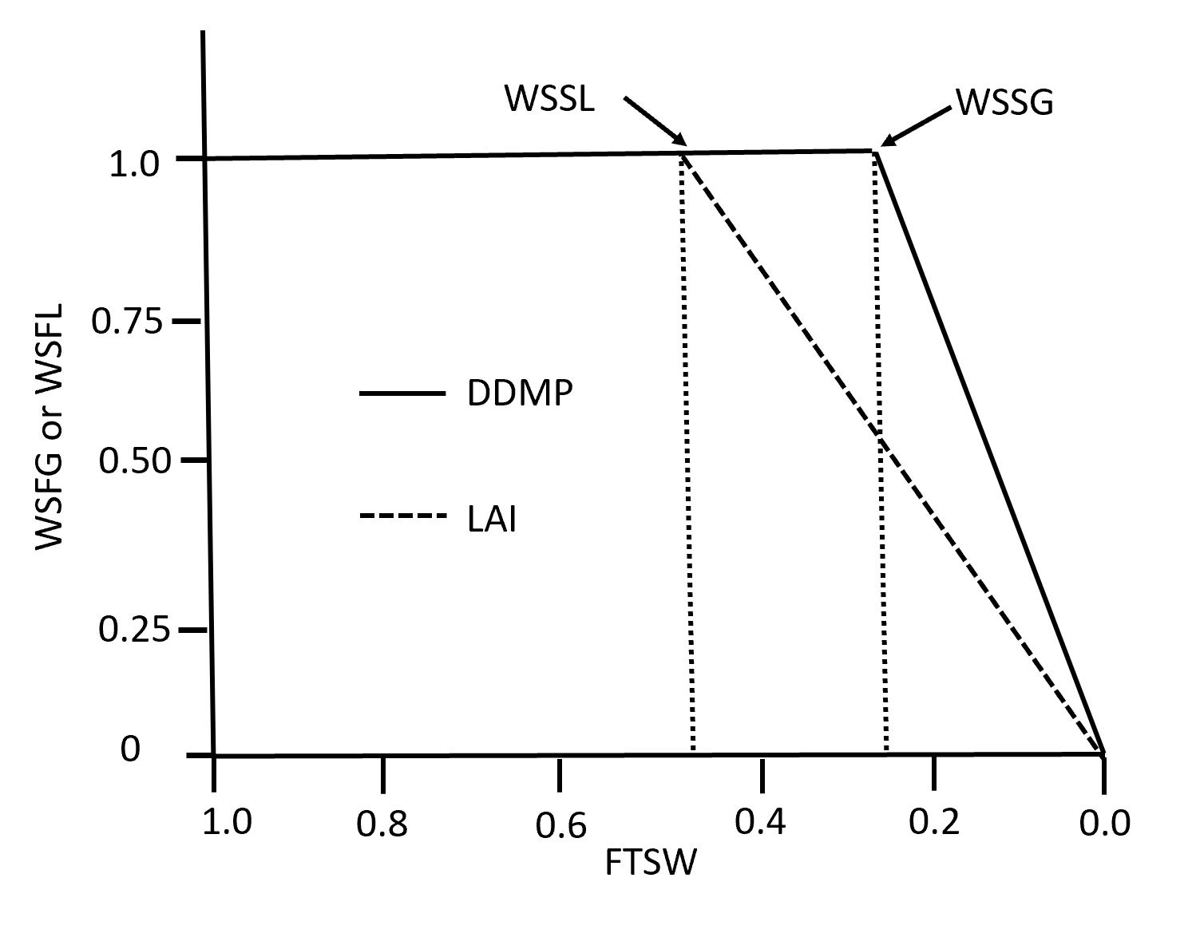

**Growth and Transpiration**

When FTSW is greater than the growth and transpiration threshold (WSSG), WSFG equals 1. Once the FSTW exceeds the threshold value, WSSG, WSFG decreases linearly. The pseudo code for this function is

If FTSW ≥ WSSG then

WSFG = 1

Else

WSFG = FTSW/WSSG

Endif

The effect on growth is simulated by reducing the radiation use efficiency in the dry matter production module.

RUE = RUE * WSFG

And

DDMP = PAR * FINT * RUE

This results in reduced DDMP which in turn effects transpiration because

TR = (DDMP * VPD) / TEC

As computed in the soil water balance module.

**Leaf Area**

The water deficit stress factor WSFL for leaf area development is computed in a similar manner with the threshold value of WSSL. (See figure above)

If FTSW ≥ WSSL then

WSFL = 1

Else

WSFL = FTSW/WSSG

Endif

In this case, the stress factor may be used to reduce the rate of LAI by either reducing the rate of the appearance of new nodes on the main stem (INODE) or the rate of leaf area growth GLAI by

INODE = INODE * WSFL

or

GLAI = GLAI * WSFL

Use of these equations depends on whether the plant responds by slowing down the rate of leaf appearance (former eqn.) or decreases the leaf expansion rate and size (latter eqn.).

**Phenological Development**

The water stress factor for phenological development (WSFD) is related to FTSW through the water stress factor for growth and transpiration (WSFG). Thus after WSFG is calculated as described above, WSFD is calculated from the function.

WSFD = (1 – WSFG) * WSSD + 1

Where WSSD is the phenological water stress coefficient. It is thought that the ratio of leaf temperature in a water stressed plant to a well-watered one might be a measure of WSSD. Note: WSFG = 1 until FTSW < |WSSG| therefore WSFD = 1 until FTSW < |WSSG| meaning phenological development will not change until growth (DDMP) and transpiration decrease.

The larger the value of WSSD the more water stress affects phenological development. Water stress affects phenological development of plants differently. In some, it accelerates phenological stages and in others it retards development. These differences can be represented by changing the sign of WSSD. A positive value increases the rate while a negative one decreases it. (See figure below and Table 15.3 pg 199 for examples of both)

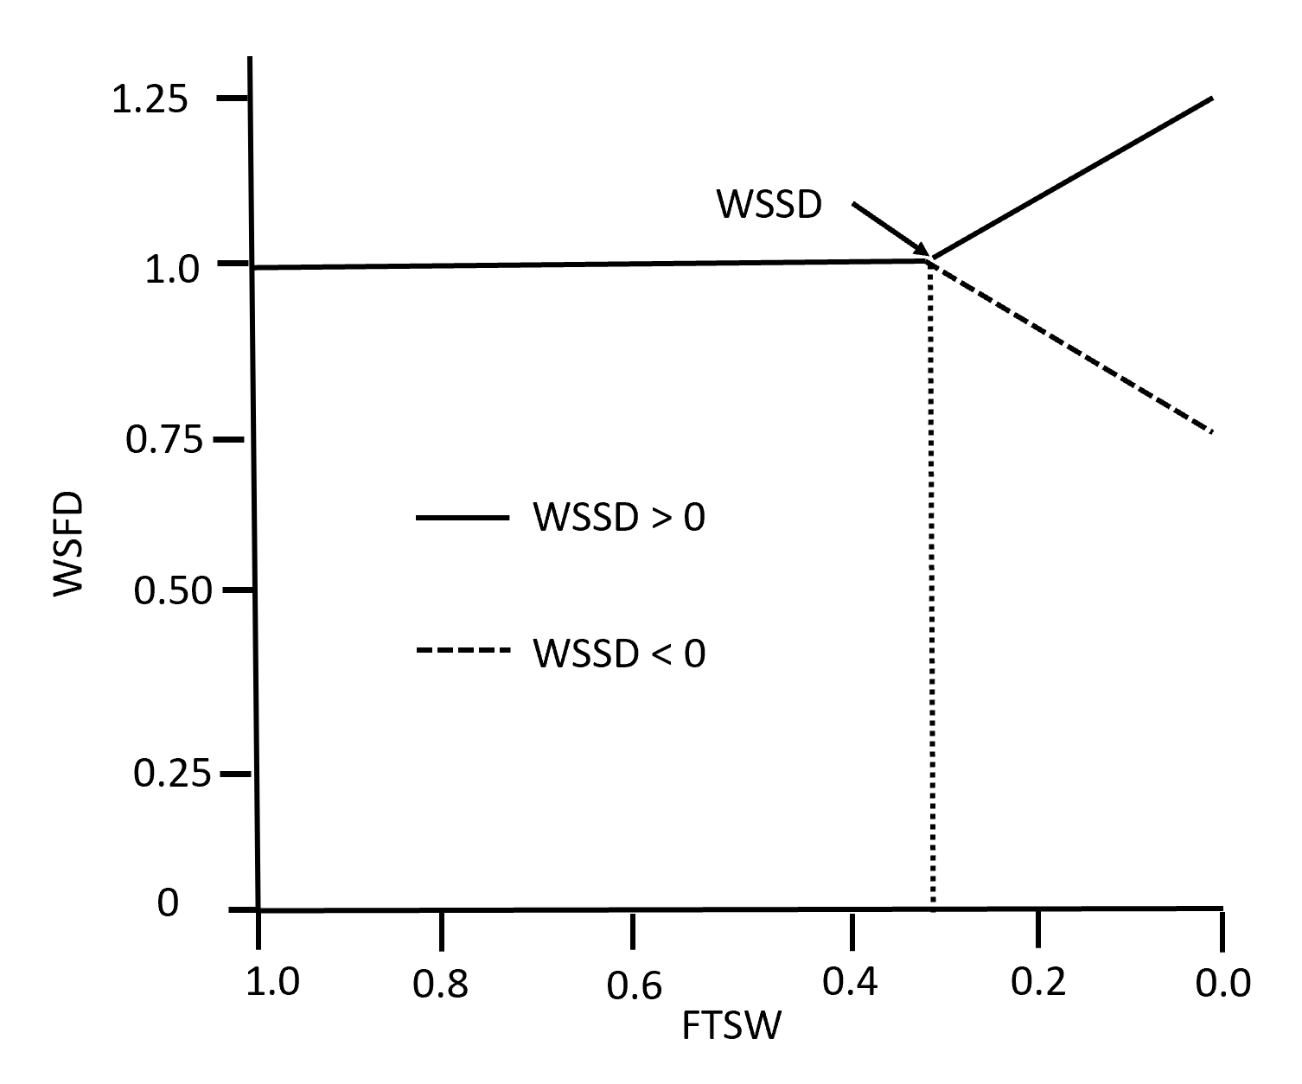

The change in the phenological development rate is obtained by multiplying the daily temperature unit (DTU) by the water stress factor.

DTU = DTU * WSFD

**Crop Termination due to Water-deficit or Excess Stresses**

A combination of very low transpirable water (FTSW) and high vapor pressure deficit (VPD) that occurs during some period of time can result in crop failure. Table 15.4 on pg 199 provides an example of these combinations.

Excessive soil moisture over some period of time can also reduce physiological processes. In the SS spreadsheet model these conditions are implemented by setting all the stress factor equal to zero. The pseudo code for this effect in the SS model is implemented in layer 1.

If WAT1 > 0.95 * WSAT1 then

WSAT = WSFL = WSFG = WSFD = WSFN = 0

Endif

Note: WSFN is the soil nitrogen stress factor. (See Chapter 17)

**Chapter 16 A Model for Water Limited Conditions**

The structure of the SS Water Limited spreadsheet model (SSWLM) is similar to the SS Potential Production model. To include the soil water effects, 3 additional variables are added to the **ManageInputs** module. These variables include:

**water** – a decision variable controlling whether and how the water limited algorithms are included in the simulation.

water = 0 implies that soil conditions and water stress factors are not included in the simulation.

water = 1 implies irrigation water is applied based on the IRGLV parameter and growth stage.

water = 2 implies a rainfed simulation without irrigation is performed.

Note: The SS Water Limited model does **NOT** allow the simulation of both rainfall and irrigation.

**VPDF** - vapor pressure deficit coefficient controls how VPD is calculated in Eqn. 14.21 pg 162. The SSWLM suggests:

VPFD = 0.65 in humid & sub-humid climates

VPFD = 0.75 in arid and semi-arid climates.

**IRGLV** – a decision variable representing the fraction of transpirable (FTSW) at which irrigation water will be applied. Additionally, irrigation only occurs before the termination of seed growth (CTU < tuTSG). The amount of irrigation water applied is computed as the difference between total transpirable soil water (TTSW) and the actual transpirable soil water (ATSW) in the root zone (DEPORT).

Additional **soil parameters** that must be specified when water = 1 or water = 2 include:

**SOLDEP** (mm) - total soil depth

**DEP1** (mm) - total soil depth layer 1

**SALB** (ND) - soil albedo

**CN** (ND) - soil curve number

**DRAINF** (day-1) - drainage rate factor

**SAT** (mm H20 mm-1 soil) - soil water content at saturation

**DUL** (mm H20 mm-1 soil) - drainable upper limit (field capacity)

**EXTR** (mm H20 mm-1 soil) - crop extractable soil water

**MAI** (mm H20 mm-1 soil) - initial soil profile simulation soil moisture availability index

**MAI1** (mm H20 mm-1 soil) - initial layer 1 simulation soil moisture availability index

**EOSMIN** (mm H20 day-1) - minimum daily soil evaporation

**WETWAT** (mm H20 mm-1 soil) - amount of RAIN or applied irrigation water required to wet layer 1 to return from Stage II soil evaporation to Stage I soil evaporation

It is important to note that the SSWLM spreadsheet model does **not** allow the simulation of both irrigation and rain fed crops in the same simulation.

Additional **crop parameters** that must be specified when water = 1 or water = 2 include:

**DEPORT** (mm) - initial root zone depth

**MEED** (mm) - maximum root zone depth

**GRTDP** (mm day-1) - daily increase in root zone depth

**TEC** (Pa) - transpiration use efficiency

**WSSG** (ND) - FTSW threshold for decline in dry matter production

**WSSL** (ND) - FTSW threshold for decline in LAI

**WSSD** (ND) - FTSW threshold for change crop phenology

**KET** (ND) - canopy light extinction coefficient

**CALB** (ND) - canopy albedo coefficient

**tuBRG** (oC) - temperature units required for beginning of root growth

**tuTRG** (oC) - temperature units required for termination of root growth

A diagram of SSWLM is presented on the flow chart figure below.

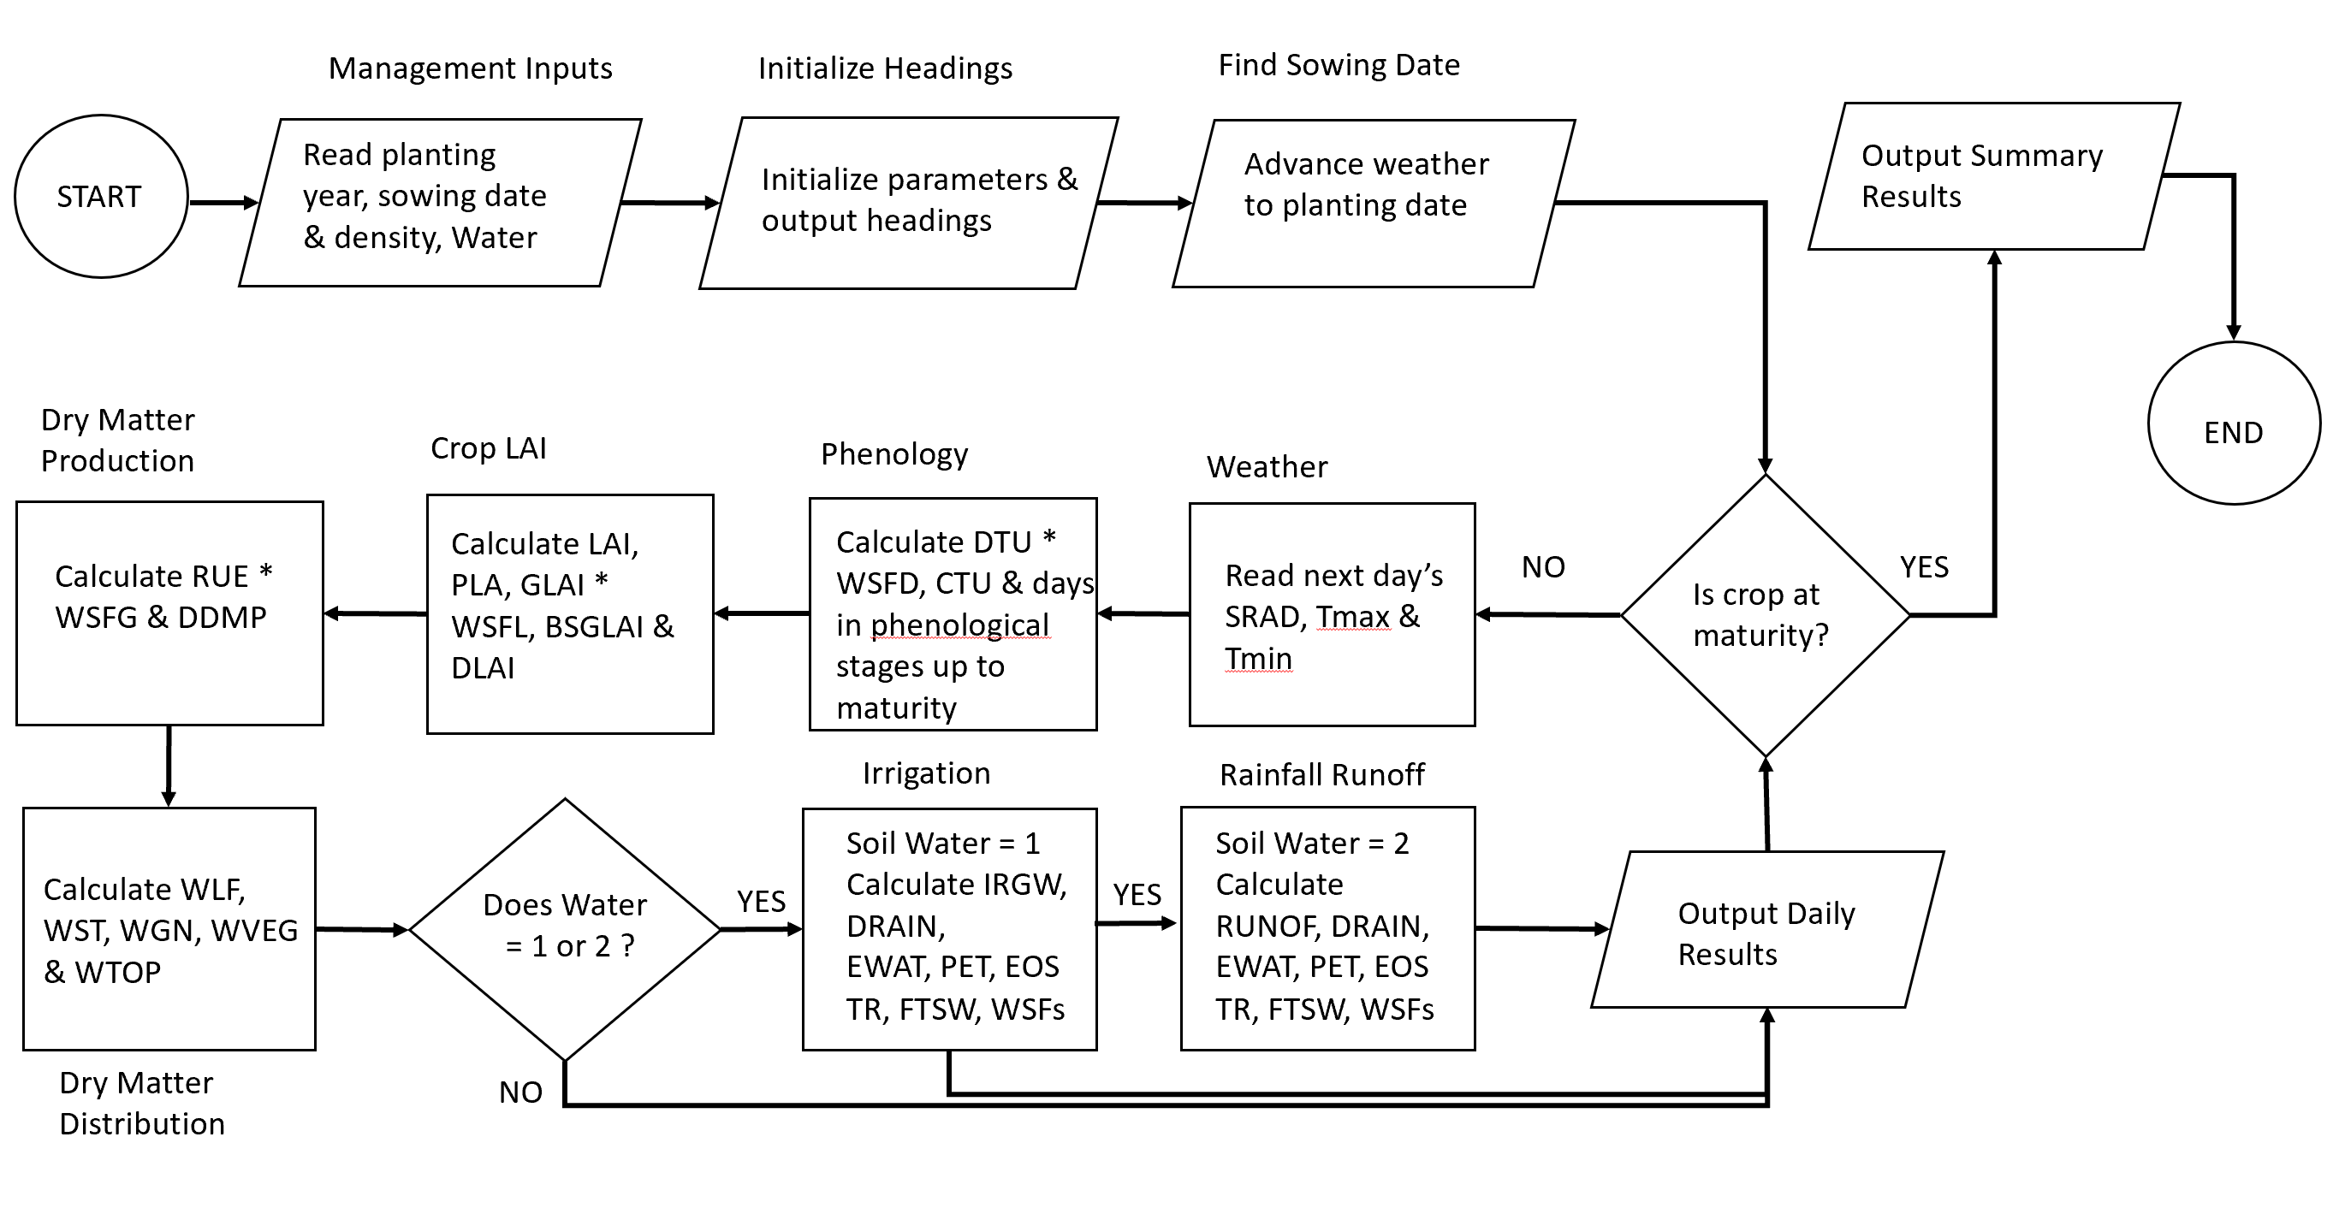

A description of the SSWLM code is presented below. As the flow chart above demonstrates, the basic structure of the Potential Production model described above in Chapter 12 remains the same. The description of this code will not be repeated. However, there are some differences that will be described here. (See Box 15.1 pg 201 and Box 15.2 pgs 202 – 211) In the **Main Program,** **ManageInputs, Weather, Phenology CropLAand I DMProduction** modules are called sequentially . Finally, if **water** = 1 or 2 then the **SoilWater** module is included in the simulation.

The modified **ManageInputs module** now contains three additional input variables including **water**, **VPDF** and **IRGLVL** as described above.

The **Weather module** is unchanged.

The **Phenology module** has a slight modification to account for the effect of water stress on phenological development. The water stress factor for phenological development (**WSFD**) is initially set equal to 1. In modified module, daily temperature units (DTU, oC) are modified by multiplying by WSFD. The WSFD is re-computed based on FTSW on a daily basis along with other water stress factors in the **SoilWater module**.

The temperature unit calculation is affected by the WSFD code modifications are bolded below.

DTU = (TP1D - TBD) * tempfun

If CTU > tuEMR Then DTU = DTU * **WSFD**

CTU = CTU + DTU

The **CropLAI module** also has a slight modification to account for the effect of water deficit stress on LAI. In this case, the daily rate of LAI increase (GLAI, mm2 leaf area mm-2 ground day-1) is multiplied by the current water stress factor for leaves, **WSFL**. The initial value of WSFL is initially set equal to 1. It is subsequently re-computed daily based on FTSW along with other water stress factor in the **SoilWater module**. The code modification for this effect is bolded below.

If CTU <= tuEMR Then

GLAI = 0: DLAI = 0

ElseIf CTU > tuEMR And CTU <= tuTLM Then

INODE = DTU / PHYL

MSNN = MSNN + INODE

PLA2 = PLACON * MSNN ^ PLAPOW

GLAI = ((PLA2 - PLA1) * PDEN / 10000) * **WSFL**

PLA1 = PLA2

DLAI = 0

The **DMProduction module** also has a slight modification to account for the effect of water stress factor, WSFG on RUE. **WSFG** is initially set equal to 1. It is subsequently re-computed daily along with other water stress factors in the **SoilWater module**. The code modification for this effect is bolded below.

'------------------------------- Adjustment of RUE

RUE = IRUE * TCFRUE * **WSFG**

In the **SoilWater module**, the initial parameters are used to compute the following variables:

**CLL** = DUL – EXTR - soil water below the crop’s lower limit of transpirable soil water (mm H2O mm-1 soil)

**IPATSW** = SOLDEP * EXTR * MAI - initial actual transpirable soil water in the soil profile at sowing (mm)

**ATSW** = DEPORT * EXTR * MAI1 - initial transpirable soil water in the root zone at sowing (mm)

**TTSW** = DEPORT * EXTR - total transpirable soil water in the root zone at sowing (mm)

**FTSW** = ATSW / TTSW - fraction of transpirable soil water in the root zone at sowing (ND)

**WSTORG** = IPATSW – ATSW - total soil water in storage below root zone at sowing (mm)

**ATSW1** = DEP1 * EXTR * MAI1 - initial transpirable soil water in layer 1 at sowing (mm)

**TTSW1** = DEP1 * EXTR - total transpirable soil water in layer 1 at sowing (mm)

**FTSW1** = ATSW1 / TTSW1 - fraction of transpirable soil water in layer 1 at sowing (ND)

**WLL1** = DEP1 * CLL - amount of soil water below the crop’s lower transpirable limit in layer 1 (mm)

**WAT1** = WLL1 + ATSW1 - amount of soil water in layer 1 (mm)

**WSAT1** = DEP1 * SAT - amount of soil water at saturation in layer 1 (mm)

The following accumulator variables must also be initialized.

**DYSE** = 1 - days since the last rain or irrigation wetted layer 1 (days)

**CTR** = 0 - Cumulative transpiration (mm)

**CE** = 0 - Cumulative soil evaporation (mm)

**CRAIN** = 0 - Cumulative rain (mm)

**CRUNOF** = 0 - Cumulative runoff (mm)

**CIRGW** = 0 - Cumulative irrigation water applied (mm)

**IRGNO** = 0 - Number of irrigations (ND)

After the input and initialization of these parameters, the first sub-module that is executed is the **Irrigation module**. The code for this sub-module follows.

If water = 1 then # If True: Crop is irrigated

If FTSW ≤ IRGLVL then # if True: Crop needs irrigation water

# Note: FTSW = ATSW / TTSW

If CTU < tuTSG then # If True: Irrigate prior to termination of seed growth

IRGW = (TTSW – ATSW) # Amount of irrigation water applied

IRGNO = IRGNO + 1 # Increment the no. of irrigations

Else

IRGW = 0 # No irrigation

Else

IRGW = 0 # No irrigation

Endif

CIRGW = CIRGW + IRGW # Increments cumulative amount of irrigation water. Note – this requires IRGW to be set to 0 even when water ≠ 1 This logic could be simplified by setting IRGW = 0 before the IF water = 1 is executed.

**Drainage** is the next sub-module to be executed.

Layer 1 drainage (DRAIN1) is computed first.

If ATSW1 <= TTSW1 Then # No drainage when the actual transpirable soil water ≤ the total transpirable soil water in layer 1. Note - TTSW1 = DEP1 * EXTR is a constant throughout the simulation. It is the plant available water holding capacity (AWHC) of layer 1 with a thickness of DEP1.

DRAIN1 = 0

ElseIf ATSW1 > TTSW1 Then

DRAIN1 = (ATSW1 - TTSW1) * DRAINF # This is the drainage from layer 1 that brings it back to TTSW1. This is done in the updating section later. DRAINF is the rate of drainage where 1 => it drains in 1 day & 0.5 => it drains in 2 days … etc.

End If

The drainage from the root zone (DEPORT) is calculated next in the **Drainage** procedure.

If ATSW <= TTSW Then # Both ATSW & TTSW are updated on a daily basis in the updating section. In this case, TTSW increases because the root zone thickness (DEPORT) is increasing at a specified rate GRTD which is a variable computed in the water exploitation by root growth procedure (See below).

DRAIN = 0

ElseIf ATSW > TTSW Then

DRAIN = (ATSW - TTSW) * DRAINF

End If

The available soil water stored below the root zone is then calculated.

WSTORG = WSTORG + DRAIN – EWAT # Note: DRAIN is water added to storage below the root zone while EWAT is water entering the root zone due to root expansion. EWAT was not initially defined. What value it has on the initial day is problematic. I think it could be initialized = 0 because GRTD = 0 until CTU ≥ tuBRG.

If WSTORG < 0 Then WSTORG = 0

**Water exploitation by root growth** is calculated next.

GRTD = GRTDP # GRTDP is the input parameter defining the root growth rate in mm per day.

If CTU < tuBRG Then GRTD = 0 # Cumulative temperature units required to begin root growth.

If CTU > tuTRG Then GRTD = 0 # Cumulative temperature units at termination of root growth.

If DDMP = 0 Then GRTD = 0 # If no dry matter produced => no root growth.

If DEPORT >= SOLDEP Then GRTD = 0 # If root zone reaches max soil depth => no root growth.

If DEPORT >= MEED Then GRTD = 0 # If root zone reaches maximum effective depth of water extraction => no root growth.

If WSTORG = 0 Then GRTD = 0 # If no water in storage below root zone => no root growth.

DEPORT = DEPORT + GRTD # This is the new root zone depth.

Calculate the amount of available soil water added to the root zone due to root growth.

EWAT = GRTD * EXTR # Note: EWAT is calculated here after it is used above.

If EWAT > WSTORG then EWAT = WSTORG # Note: EWAT decreases WSTORG so eventually it could become greater than WSTORG.

**Runoff of rainfall** is calculated next.

RUNOF = 0 # Note: RUNOF is specified on a daily time step even if runoff calculation is not performed.

If water = 2 And RAIN > 0.01 Then # Note: As implemented in the SS spreadsheet model you can’t have both irrigation and rain feed crops.

S = 254 * (100 / CN - 1) # Calculate the soil retention parameter from curve number.

SWER = 0.15 * ((WSAT1 - WAT1) / (WSAT1 - WLL1)) # Calculate soil water runoff coefficient. Note WSAT1 = saturated soil water content of layer 1, WAT1 is the actual water content in layer 1 and is a function of ATWS1 which is updated daily and WLL1 is the soil water below the plant’s extraction limit.

If SWER < 0 Then SWER = 0 # SWER = 0 could only happen if WAT1 > WSAT1

If (RAIN - SWER * S) > 0 Then # If True, calculate runoff

RUNOF = (RAIN - SWER * S) ^ 2 / (RAIN + (1 - SWER) * S)

Else

RUNOF = 0

End If

End If (water = 2 And RAIN > 0.01)

Adjust runoff for soil water in excess of saturation after drainage.

If (WAT1 - DRAIN1) > WSAT1 Then

RUNOF = RUNOF + (WAT1 - DRAIN1 - WSAT1)

End If

Accumulate the rainfall and runoff.

CRAIN = CRAIN + RAIN

CRUNOF = CRUNOF + RUNOF

The **Soil Evaporation** calculation involves three steps.

1. Obtaining the **appropriate LAI**
2. Calculating the **potential ET** (PET)
3. Computing the **soil evaporation (SEVP)**.

**LAI adjustment**

If CTU <= tuBSG Then ETLAI = LAI Else ETLAI = BSGLAI # After the beginning of seed growth, there is no additional increase in LAI but senescenced leaves remain on crop.

**Calculation of PET using Richie’s modified Priestly-Taylor method.**

TD = 0.6 * TMAX + 0.4 * TMIN # Note: weighted equilibrium evaporation temperature (TD) is calculated

ALBEDO = CALB * (1 - Exp(-KET * ETLAI)) + SALB * Exp(-KET * ETLAI) # Crop albedo (CALB) * fraction of canopy coverage and soil albedo (SALB) * fraction of soil surface uncovered

EEQ = SRAD * (0.004876 - 0.004374 * ALBEDO) * (TD + 29) # Equilibrium evaporation

PET = EEQ * 1.1 # 1.1 accounts for effect of unsaturated air

If TMAX > 34 Then PET = EEQ * ((TMAX - 34) * 0.05 + 1.1) # Increase allows for advection

If TMAX < 5 Then PET = EEQ * 0.01 * Exp(0.18 * (TMAX + 20)) # Decrease accounts for frozen soil and stomatal closure at low temperature

**Potential soil evaporation (EOS)**

EOS = PET * Exp(-KET * ETLAI) # Potential soil evaporation based on uncovered soil surface

If PET > EOSMIN And EOS < EOSMIN Then EOS = EOSMIN # Adjusts for user specified minimum soil evaporation when PET > EOSMIN

SEVP = EOS

If (RAIN + IRGW) > WETWAT Then

DYSE = 1 # Returns soil evaporation to Stage I. Note: DYSE is days since last rain.

If DYSE > 1 Or FTSW < 0.5 Then # Conditions for reduced soil evaporation in Stage II Note: FTSW refers to the root zone.

SEVP = EOS * ((DYSE + 1) ^ 0.5 - DYSE ^ 0.5) # Increases reduction in soil evaporation due to drying.

DYSE = DYSE + 1 # Increments the days since last RAIN or Irrigation

End If

**Accumulated soil evaporation**

CE = CE + SEVP

The next sub-module is the **Plant Transpiration**. First, the vapor pressure deficit (VPD) is calculated and then plant transpiration (TR) in the root zone and layer 1 (TR1) are computed.

VPTMIN = 0.6108 * Exp(17.27 * TMIN / (TMIN + 237.3)) # Saturation vapor pressure at TMIN

VPTMAX = 0.6108 * Exp(17.27 * TMAX / (TMAX + 237.3)) # Saturation vapor pressure at TMAX

VPD = VPDF * (VPTMAX - VPTMIN) # This equation is very different from the ASCE VPD equations. Note VPDF is a user specified parameter.

TR = DDMP * VPD / TEC # Note: DDMP (g m-2 day-1), VPD (kPa), TEC (Pa) TR is linked with dry matter production (DDMP) & transpiration use efficiency (TEC) a crop parameter.

If TR < 0 Then TR = 0 # Not sure why this would be necessary

Now **TR in layer 1** is computed.

If DEPORT <= DEP1 Then # True => root zone is in layer 1

TR1 = TR

ElseIf DEPORT > DEP1 Then # True => root zone below layer 1

If FTSW1 > WSSG Then # True => Soil water content in layer 1 is not limiting dry matter production

RT1 = 1

Else

RT1 = FTSW1 / WSSG # True => Dry matter production is limited by soil moisture content in layer 1.

Endif

TR1 = TR * RT1 # TR from layer 1 is the same as in the rest of the root zone unless the fraction of transpirable water is below the dry matter production threshold (WSSG).

End If

The **transpireable soil water in layer 1** is updated next.

ATSW1 = ATSW1 + RAIN + IRGW - DRAIN1 - RUNOF - TR1 – SEVP # Updated layer 1 actual transpirable soil water.

If ATSW1 < 0 Then ATSW1 = 0 # Not sure why this is necessary.

FTSW1 = ATSW1 / TTSW1 # Calculate fraction of transpirable water in layer 1 Note: TTSW1 is a constant value.

WAT1 = WLL1 + ATSW1 # Calculate total soil water in layer 1 Note: WLL1 is a constant value.

and then **transpirable water in the root zone** is updated.

ATSW = ATSW + RAIN + IRGW + EWAT - DRAIN - RUNOF - TR – SEVP

If ATSW < 0 Then ATSW = 0 # Not sure why this would be needed.

TTSW = DEPORT * EXTR # Update total transpirable water in updated root zone.

FTSW = ATSW / TTSW # Update the fraction of transpirable water in root zone.

Finally the **water-stress factors** are updated.

If FTSW > WSSL Then # True => Increase in LAI not affected by lack of transpirable soil water.

WSFL = 1

Else

WSFL = FTSW / WSSL # Calculate LAI reduction factor.

Endif

If FTSW > WSSG Then # True => Dry matter production not affected by lack of transpirable soil water.

WSFG = 1

Else

WSFG = FTSW / WSSG # Calculate the reduction factor.

Endif

WSFD = (1 - WSFG) * WSSD + 1 # Calculate the phenological development factor. Note – WSSD is the rate of increase (WSSD > 0) or decrease (WSSD < 0).

If WAT1 > (0.95 * WSAT1) Then # True => actual soil water in layer 1 > 95% of saturation.

WSFG = 0: WSFL = 0: WSFD = 0 # Crop development is stopped until enough drainage occurs.

End If

**Chapter 17 Plant Nitrogen Budget**

Leaves require nitrogen (N) as a critical component of the enzymes that carry on photosynthesis and sugar production. Nitrogen deficit limits leaf area development but dry matter accumulation by leaves is less affected resulting in an increased specific leaf weight. Figure 17.1 pg 220 shows that at a given leaf nitrogen content (g N m-2 leaf) reducing the nitrogen supply rate (g N m-2 day-1) reduces the LAI.

Both carbon dioxide exchange rates (CER, mg CO2 m-2 s-1) and RUE (g MJ-1) are sensitive to leaf N content at low leaf N content but become increasing less sensitive as leaf N content increases (See Fig 17.2 & 17.3 pg 221) reaching maximum CER and RUE at high leaf N content. Experimental studies have shown that leaf N at the top of mature canopies is substantially greater than in canopies with expanding LAI. Leaf N at the canopy top was such that these leaves approached maximum photosynthetic rates. This non-uniform distribution of N content enhances the canopy RUE by insuring the leaves that receive the most solar radiation have the highest N content.

An important aspect of the plant N budget is the role of crop leaves as storage of N for translocation to growing seeds. In general, there is a direct relationship between LAI and grain yield. (See Figure 17.4 pg 222). N accumulation after BSG is negligible. Therefore, seed growth is very dependent on translocation of N from leaves and stems to the seeds. This results in leaf senescence. However, N supply from roots continues and as shown on Figure 17.5 directly affects the final grain yield.

In general, N demand is computed based on crop mass growth and N concentration in plant tissues. Accumulated N is partitioned in proportion to their individual demands. If demand exceeds supply, there is a deficiency. During grain growth, N demand is computed by multiplying grain growth rate by the anticipated grain N concentration.

In order to simulate genotypic and environmental control of crop N dynamics, it is necessary to account for both the metabolic (leaves) and structural (stems) demands for N. In this approach, N demand is set by the need to maintain target concentrations in new leaves. If available N is not sufficient for expansion, leaves become thicker. Stems act as reservoirs for extra N between minimum and target concentrations.

An overview of the plant N budget approach is summarized below.

N accumulation during vegetative growth (EMR to TLM).

* Daily N demand (NUP) is obtained from daily development in LAI (GLAI) and growth in stem weight (WSY including actual stems, leaf sheaths or petioles) and their target concentrations (SLNG & SNGC).
* NUP is adjusted for maximum capacity of the N accumulation rate as affected by flooding condition, and soil available N for crop uptake.
* N is distributed to the leaves and stems based on their demands.
* Under limited N conditions, first, stem N is reduced to its minimum; second leaf expansion is limited and finally leaves are reduced to maintain stem growth at its minimum N content.

**Plant N budget during vegetative growth (EMR to TLM)**

Prior to emergence there is no demand for N (NUP = 0)

In **non-legume plants**, the daily demand for N accumulation (NUP, g N m-2 day-1) is computed from the N requirements of leaves and stems. For leaves, the daily N demand is computed as the product of the daily increase in LAI, GLAI (m2 m-2 day-1) and the target N content per unit leaf area, SLNG (g N m-2). Similarily, the daily stem demand is computed by the product of the daily increase in stem dry matter, GST (g m-2 day-1) and the target N content per unit stem weight, SNCG (g N g-1). Therefore,

NUP = (GLAI * SLNG) + (GST * SNCG)

Both SLNG and SNCG are the target N contents when N is not limited.

It is possible to simulate daily N demand that resulted from deficiencies that developed in the plant earlier in the season, NSTDF (g m-2).

NSTDF = min (WST*SNCG – NST, 0)

Where WST is the accumulated stem dry weight and NST is the accumulated N content in the stems

In this case

NUP = (GLAI * SLNG) + (GST * SNCG) + NSTDF

There are several factors which can affect the plants ability to meet its NUP requirement. The first is that plants are limited in their ability to process N. This limitation is expressed as the maximum daily rate of N accumulation, MXNUP (g N m-2 day-1). Second, when hyperoxic conditions occur at or near (95%) soil saturation (FTSW1 > 1) then NUP = 0. (See Chapter 14) Third, NUP can be limited by soil available N for crop uptake, SNAVL (g N m-2). In this case, NUP is limited to SNAVL. (See Chapter 18). Finally, if there is no daily dry matter production, DDMP (g m-2 day-1) then NUP = 0. This occurs because it has been assumed all DDMP is distributed to seeds between BSG and TSG. (See discussion pg 228 for alternative approaches).

If NUP > MXNUP then NUP = MXNUP

IF FTSW1 > 1 then NUP = 0

IF NUP > SNAVL then NUP = SNAV

IF DDMP = 0 then NUP = 0

These factors are diagrammed below.

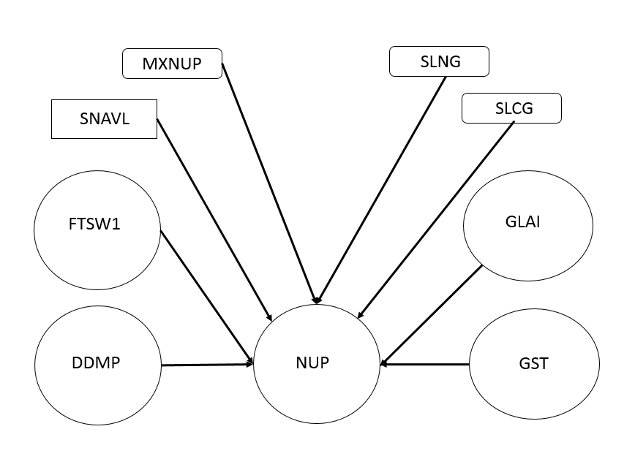

In the vegetative phase (**EMR to BSG**), N is preferentially allocated to the leaf demand. This allocation continues until yesterday’s accumulated N in the stems, NST ( g N m-2) become less than the minimum needed for stems which is the product of the accumulated stem dry matter, WST (g m-2) and the minimum stem nitrogen concentration in senesced stems, SNCS ( g N g-1). This condition is expressed as:

NST < WST * SNCS

Until this condition becomes true, the daily increase in leaf nitrogen, INLF (g N m-2) is computed by:

INLF = GLAI * SLNG (This represents the full leaf demand. See above)

And there is no mobilization of nitrogen from the leaves to the stems, XNLF (g N m-2 day-1)

XNLF = 0

If INLF is not greater than NUP, the remaining NUP is provided to the stems, INST (g N m-2).

INST = NUP – INLF

And there is no mobilization of N from the stems, XNST (g N m-2 day-1)

XNST =0

Otherwise, if INLF is greater than NUP. There is a need for additional N by mobilization from the stems to the leaves. First is no increase in stem N.

INST = 0

The amount of N transferred from the stems is the lessor of either:

XNST = INLF – NUP (leaf demand – total demand)

Or

XNST = NST – (WST * SNCS) (Accumulated stem N – target stem N)

The final result is:

INLF = NUP + XNST

The schematic for this logic is shown on the left-hand side of the flow chart below.

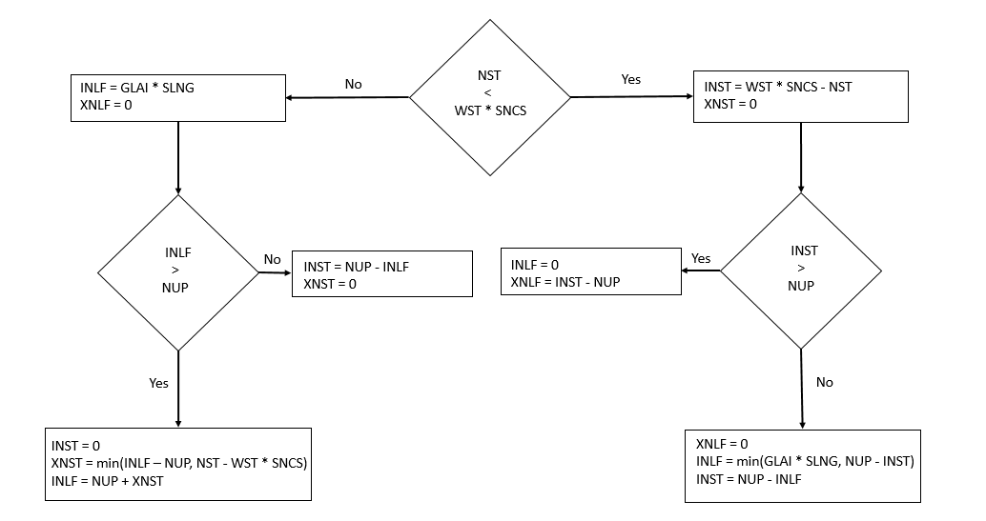

When the accumulated N content of the stems (NST) becomes lower than its minimum target (WST * SNCS), N is supplied to the stems (See right side of flow chart diagram).

First, the daily increase in stem N is calculated.

INST = WST * SNCS – NST

And mobilization of N from the stems, XNST (g N m-2 day-1) is terminated.

XNST = 0

Next, it is necessary to determine how much mobilization from the leaves to the stems is necessary. If INST is greater than the whole plant demand, no N is supplied to the leaves.

INLF = 0

Rather leaf N if mobilized in the amount of

XLNF = INST – NUP

This transfer of N from leaves to stems results in the senescence of leaves, DLAI (m2 m-2 day-1). This requires a modification of the LAI module described above.

Note - This code is included at the end of this section.

However, if NUP is greater than INST, there is no mobilization of N from the leaves.

XNLF = 0

The daily increase in leaf N (INLF) is computed as the lessor of the leaf demand

INLF = GLAI * SNLG

Or

INST = NUP – NST (Plant demand – the stem N content)

The daily increase in stem N is computed as

INST = NUP – INLF

**The N budget during seed growth (BSG to TSG)**.

* All seed demand for N is supplied by N mobilization from leaves and stems.
* The fraction of N supplied by leaves and stems is proportional to their relative mobilizable N.
* N mobilization from leaves results in leaf senescence.

After the beginning of seed growth, seeds become the primary sink for N. The daily N demand by seeds, INGRN (g m-2 day-1) is calculated as the product of the seed growth rate, SGR (g m-2 day-1) and the grain N concentration, GNC (g N g-1).

INGRN = SGR * GNC

Therefore, the daily N demand, NUP, is equal to INGRN.

NUP = INGRN

This NUP is subject to the same limitations as occurs in the vegetation growth phase. (See diagram above) Not all N in the leaves and stems can be translocated to the seeds, TRLN (g N m-2). The mobilizable N in the leaves is related to the difference between the green leaf (SLNF) and senesced leaf (SNCS) N concentrations and the amount of LAI. Similarly, translocatable N in the stems is the difference between the accumulated N (NST) and the minimum structural N (WST * SNCS).

TRLN = LAI * (SLNG – SLNS) + (NST – WST * SNCS)

Each day, the N demands of the seeds are met by translocating some of this N. To track the physiological impact of mobilization of N from the leaves, it is necessary to account for the amount of N remaining in the leaves. The proportion of the daily transfer from leaves (FXLF) to seed is equal to the N proportion that is in the leaves.

FXLF = LAI * (SLNG – SLNS) / TRLN

The daily decreases in in leaf (XNLF) and stem N (XNST) are computed as:

XNLF = (SGR * GNC) * FXLF

XNST = (SGR * GNC) * (1 – FXLF)

Crop models are different with respect to the effect of the decrease in leaf on LAI and RUE. Some model simulate the effects on both LAI and RUE and other models on only one or the other. In this model, it is assumed that the transfer reduces the LAI but has no effect on RUE because SLNG remains a constant throughout the simulation. The main reason for this assumption is that changes in leaf N throughout the canopy are not uniform. The N content of leaves near the top of the canopy remain high so RUE in these leaves remains nearly optimal during seed filling.

Under limited N conditions, the accelerated transfer of N from the leaves results in a loss of crop productivity because of a reduction in LAI due to the transfer. This loss of LAI, DLAI (m2 m-2 day-1) is computed from the leaf N loss, XLNF, and the translocatable N (SLNG – SLNS).

DLAI = XLNF / (SLNG –SLNS)

This equation is used in the LAI module as a replacement for the DTU based equation.

DLAI = BSGLAI * DTU / (tuMAT – tuBSG)

The pseudo code of the N based LAI is included at the end of this chapter.

The **non-legume N module** has the following pseudo code.

The following parameters are initialized.

SLNG, SLNS, SNCG, SNCS, GNC & MXNUP

And initial values are set.

(Note – variables that are computed in other modules are highlighted in yellow)

NST = WST * SNCG: NLF = LAI * SLNG:

CNUP = NST + NLF: NGRN = 0:

If CTU <= tuEMR Or CTU > tuTSG Then (There is no demand for N before EMR or after TSG)

NUP = 0: XNLF = 0: XNST = 0:

INLF = 0: INST = 0: INGRN = 0:

ElseIf CTU > tuEMR And CTU < tuBSG Then **(Vegetative stage)**

INGRN = 0

NSTDF = (WST * SNCG) – NST (Accumulated N deficit)

If NSTDF < 0 Then NSTDF = 0 (There is no N deficit)

NUP = (GST * SNCG) + (GLAI * SLNG) '+ NSTDF '<----- Inactive! (Total plant demand)

**Note – The following conditions reduce NUP to less than the actual plant demand**

If NUP > MXNUP Then NUP = MXNUP (Limit to crop maximum parameter)

If NUP < 0 Then NUP = 0

If FTSW1 > 1 Then NUP = 0 (Calculated in soil water module)

If DDMP = 0 Then NUP = 0 (Calculated in the Dry Matter Production module)

If NUP > SNAVL Then NUP = SNAVL (Calculated in the soil nitrogen module, see Chapter 18)

If NST <= (WST * SNCS) Then (Testing whether accumulated stem N ≤ minimum needed for stems. If true, stems have priority for daily N increase)

INST = WST * SNCS – NST (Determine the N deficit and the needed daily increase in stem N)

XNST = 0 (No decrease in stem N)

If INST >= NUP Then (Is the needed daily increase in stem N greater than NUP?, If true,)

INLF = 0 (No increase in leaf N)

XNLF = INST – NUP (Decrease leaf N which will decrease LAI (senescence))

ElseIf INST < NUP Then (Is needed increase in stem N < NUP)

INLF = GLAI * SLNG (leaf N demand today)

If INLF > (NUP - INST) Then INLF = NUP – INST (Is the daily increase in leaf N < NUP, If true, provide the leaves with difference between NUP and the stem deficit)

INST = NUP – INLF (Remainder to stems)

XNLF = 0 (No decrease in leaf N)

End If

ElseIf NST > (WST * SNCS) Then (Is stem N greater than minimum target? If true, leaves have priority for daily increase in leaf N)

INLF = GLAI * SLNG (Daily increase in leaf N targeted)

XNLF = 0 (No decrease in leaf N)

If INLF >= NUP Then (Is daily increase target greater than available N

INST = 0 (No increase in stem N)

XNST = INLF – NUP (Decrease stem N by difference between targeted leaf N increase and NUP)

If XNST > (NST - WST * SNCS) Then XNST = NST - WST * SNCS (If XNST > the mobilizable stem N then limit stem N decrease to the mobilizable N)

INLF = NUP + XNST (Daily leaf N increase is NUP + transfer of stem N)

ElseIf INLF < NUP Then (Daily increase is less than NUP. Therefore, there is some N available to increase the stem N.)

INST = NUP – INLF (Increase the stem N by the remaining available N)

XNST = 0 (No decrease in stem N)

End If

End If

ElseIf CTU >= tuBSG And CTU <= tuTSG Then **(Grain filling stage)**

INGRN = SGR * GNC (Daily N demand by seeds)

NUP = INGRN (Grains are only N sink)

**Note – These are the constraints on NUP in the grain filling stage.**

If FTSW1 > 1 Then NUP = 0 (Soil near saturation)

If DDMP <= (SGR / GCC) Then NUP = 0 (This constraint says that if the daily dry matter production, DDMP < the seed growth rate (SGR) divided by the grain conversion coefficient (GCC) which accounts for the type of dry matter produced (GCC < 1 for high protein & lipid seeds), then NUP = 0

If DDMP = 0 Then NUP = 0 (No dry matter production)

If NUP > SNAVL Then NUP = SNAVL (Available soil N)

**Note – These constraints do not include the following vegetative stage constraints:**

**If NUP > MXNUP Then NUP = MXNUP (Limit to crop maximum parameter)**

**If NUP < 0 Then NUP = 0**

If NUP > (SGR * GNC) Then

**'N is excess of seed needs**

INLF = 0 (No increase in leaf N)

INST = NUP - SGR * GNC (Increase stem N by difference between NUP and seed growth N)

XNLF = 0 (No translocation from leaves)

XNST = 0 (No translocation from stem)

ElseIf NUP <= (SGR * GNC) Then

**'Need to transfer N from vegetative tissue**

INLF = 0 (No increase in leaf N)

INST = 0 (No increase in stem N)

XNLF = (SGR * GNC - NUP) * FXLF (Decrease in leaf N)

XNST = (SGR * GNC - NUP) * (1 - FXLF) (Decrease in stem N)

End If

End If

**Note – Calculating total N in plant tissues**

NST = NST + INST – XNST (Total N in stems)

NLF = NLF + INLF – XNLF (Total N in leaves)

NVEG = NLF + NST (Total N in above ground plant)

NGRN = NGRN + INGRN (Total N in grain)

CNUP = CNUP + NUP (Total N in above ground plant organs)

**Note – The total translocatable N in the leaves and stems and the leaf fraction are adjusted during each time step.**

TRLN = LAI * (SLNG - SLNS) + (NST - WST * SNCS) (Total translocable N in the leaves and stems)

FXLF = LAI * (SLNG - SLNS) / (TRLN + 0.000000000001) (Fraction of total N mobilized from leaves)

If FXLF > 1 Then FXLF = 1

If FXLF < 0 Then FXLF = 0

Return

For **legume plants** the N budget is simplified because N is supplied by N2 fixation in the soil. If it is assumed that N2 fixation is sufficient, then the soil N balance calculations are not necessary. However, there are specific situations in the vegetative stage where the daily demand for N (NUP) may not be fully met. These circumstances include:

* N2 fixation is not active until a certain amount of temperature units have elapsed, tuBNF (oC).
* The daily nitrogen demand, NUP, exceeds the maximum, MXNUP.
* The soil water content decreases below a water stress factor for N fixation, WSFN. This factor is obtained from FTWS using a threshold the sensitivity of N fixation to water deficit in the crop, WSSN.
* Flooding conditions occur that prevent N accumulation when soil water content is 95% of saturation, WAT1.

The pseudo code for legume crops follows. **Note - code that differs from non-legumes is highlighted in light green.**

The following parameters are initialized.

* SLNG, SLNS, SNCG, SNCS, GNC & MXNUP
* Addition parameters for legumes include:
  + tuBNF – temperature units for initiation of N2 fixation (oC)
  + WSSN – soil water threshold (FTSW) when N fixation starts to decline
  + INSOL – intial soil N content (g N m-2)

And initial values are set.

(Note – variables that are computed in other modules are highlighted in yellow)

NST = WST * SNCG: NLF = LAI * SLNG

WSFN = 1 (Water stress factor for N fixation)

CNUP = NST + NLF: NGRN = 0:

If CTU <= tuEMR Or CTU > tuTSG Then (There is no demand for N before EMR or after TSG)

NUP = 0: XNLF = 0: XNST = 0: INLF = 0: INST = 0: INGRN = 0:

ElseIf CTU > tuEMR And CTU < tuBSG Then (**Vegetative Stage**)

INGRN = 0

NSTDF = (WST * SNCG) – NST (Accumulated N deficit)

If NSTDF < 0 Then NSTDF = 0 (There is no N deficit)

NUP = (GST * SNCG) + (GLAI * SLNG) '+ NSTDF '<----- Inactive! (Total plant demand)

**Note – The following conditions reduce NUP to less than the actual plant demand**

If CTU < tuBNF And CNUP > INSOL Then NUP = 0 **Note – INSOL computed in the Soil N module**

If NUP > MXNUP Then NUP = MXNUP

NFC = NFC * 3 / 4 + NUP / WVEG * (1 / 4) 'from Sinclair et al. 2003 Note – NFC (It’s not clear if N fixation coefficient, NFC (g N g-1 dm day-1) gets its initial value from the 2nd term of this equation in the case that NFC is initialized = 0. Need to check how VBA initializes variables. WVEG is computed in DM Distribution module.

NUP = NUP * WSFN **Note – WSFN = 0 when WAT1 > 0.95 * WSAT1 in the SoilWater module**

**Not sure how WSFN is reset if WAT1 becomes < 0.95 * WSAT1**

If NUP < 0 Then NUP = 0

If FTSW > 1 Then NUP = 0 Note – Uses soil profile water content, FTSW instead of just layer 1, FTSW1 in the NonLegume module

If DDMP = 0 Then NUP = 0

**Note – the condition If NUP > SNAVL Then NUP = SNAVL is included in NonLegumeN module but not in the Legume model.**

If NST <= (WST * SNCS) Then (Testing whether accumulated stem N ≤ minimum needed for stems. If true, stems have priority for daily N increase)

INST = WST * SNCS – NST (Determine the N deficit and the needed daily increase in stem N)

XNST = 0 (No decrease in stem N)

If INST >= NUP Then (Is the needed daily increase in stem N greater than NUP?, If true,)

INLF = 0 (No increase in leaf N)

XNLF = INST – NUP (Decrease leaf N which will decrease LAI (senescence))

ElseIf INST < NUP Then (Is needed increase in stem N < NUP)

INLF = GLAI * SLNG (leaf N demand today)

If INLF > (NUP - INST) Then INLF = NUP – INST (Is the daily increase in leaf N < NUP, If true, provide the leaves with difference between NUP and the stem deficit)

INST = NUP – INLF (Remainder to stems)

XNLF = 0 (No decrease in leaf N)

End If

ElseIf CTU >= tuBSG And CTU <= tuTSG Then **(Grain filling stage)**

INGRN = SGR * GNC (Daily N demand by seeds)

NUP = INGRN (Grains are only N sink)

PDNF = NFC * WVEG Note – PDNF is the potential rate of N fixation (g N m-2 day-1)

If PDNF > NUP Then PDNF = NUP (Limits PDNF to NUP)

DNF = PDNF * WSFN (DNF is actual rate of N fixation as limited by soil water content)

If FTSW > 1 Then DNF = 0 (Similar to NUP constraint inNonLegum module but uses whole profile fraction of transpirable water (FTSW) instead of just layer 1 (FTSW1).

If DNF < 0 Then DNF = 0

If DDMP <= (SGR / GCC) Then DNF = 0 (This constraint says that if the daily dry matter production, DDMP < the seed growth rate (SGR) divided by the grain conversion coefficient (GCC) which accounts for the type of dry matter produced (GCC < 1 for high protein & lipid seeds), then DNF = 0

If DDMP = 0 Then DNF = 0 (These constraints similar to NUP constraints in the NonLegume module)

NUP = DNF (Assign NUP the value of DNF)

If NUP > (SGR * GNC) Then

**'N is excess of seed needs**

INLF = 0 (No increase in leaf N)

INST = NUP - SGR * GNC (Increase stem N by difference between NUP and seed growth N)

XNLF = 0 (No translocation from leaves)

XNST = 0 (No translocation from stems)

ElseIf NUP <= (SGR * GNC) Then

**'Need to transfer N from vegetative tissue**

INLF = 0 (No increase in leaf N)

INST = 0 (No increase in stem N)

XNLF = (SGR * GNC - NUP) * FXLF (Decrease in leaf N)

XNST = (SGR * GNC - NUP) * (1 - FXLF) (Decrease in stem N)

End If

End If

Under limited N conditions, the accelerated transfer of N from the leaves results in a loss of crop productivity because of a reduction in LAI the transfer. This loss of LAI, DLAI (m2 m-2 day-1) is computed from the leaf N loss, XLNF, and the translocatable N (SLNG – SLNS).

DLAI = XLNF / (SLNG –SLNS)

This is the pseudo code for LAI when N effects are included in the model. Note – variables coming from other modules are highlighted in yellow and differences with non-N model are highlighted in light green.

**Read crop parameters**

PHYL (oC per leaf)

PLACON (constant multiplier for eqn relating LAI to main stem node number)

PLAPOW (power coefficient for eqn relating LAI to main stem node number)

SLA (specific leaf area m2 g-1)

**Initialize variables**

MSNN = 1 (Initial node #)

PLA2 = 0 (plant leaf area today, cm2 per plant)

PLA1 = 0 (plant leaf area yesterday, cm2 per plant)

LAI = 0 (leaf area index, m2 leaves per m2 ground surface)

MXLAI = 0 (Max leaf area, m2 m-2)

WSFL = 1 (water stress factor for leaf development)

SLNG = 2 (Target leaf N content, g N m-2)

**'------------------------------- Yesterday LAI to intercept PAR today**

If GLAI > (INLF / SLNG) Then GLAI = (INLF / SLNG) (Limit daily increase (GLAI) to the daily available N for leaf expansion)

LAI = LAI + GLAI – DLAI (Calculate cumulative LAI)

If LAI < 0 Then LAI = 0

If LAI > MXLAI Then MXLAI = LAI **'Saving maximum LAI**

**'------------------------------- Daily increase and decrease in LAI today**

If CTU <= tuEMR Then (No Leaf development or senescence before EMR)

GLAI = 0: Note – DLAI is not set to 0 here as in the CropLAI model

ElseIf CTU > tuEMR And CTU <= tuTLM Then **(Vegetative growth stage)**

INODE = DTU / PHYL (daily increase in node number, # day-1)

MSNN = MSNN + INODE (total # of nodes)

PLA2 = PLACON * MSNN ^ PLAPOW (total plant LAI today)

GLAI = ((PLA2 - PLA1) * PDEN / 10000) * WSFL (Daily increase in LAI) Note - PDEN is a management parameter

PLA1 = PLA2 (Update yesterday’s plant leaf area)

Note – DLAI is not set to 0 here as in the non N LAI model

ElseIf CTU > tuTLM And CTU <= tuBSG Then **(Transition stage before BSG)**

GLAI = GLF * SLA (Daily increase in leaf weight, GLF, is calculated in Dry Matter production module)

BSGLAI = LAI 'Saving LAI at BSG

Note – DLAI is not set to 0 here as in the non N LAI model

ElseIf CTU > tuBSG Then **(Grain filling stage)**

GLAI = 0

Note – DLAI is not computed inside this logical block as it was in the CropLAI model

End If

DLAI = XNLF / (SLNG - SLNS) (Leaf senescence based on translocation of N from leaves regardless of growth stage)

Return

**Chapter 18 Soil Nitrogen Balance**

The nitrogen (N) balance in the soil is important for the simulation of crop growth and yield because it is the nutrient required in the greatest amounts by plants. Nitrogen fertilization is also a major expense in crop production. In addition, the release of soil nitrogen into surface and groundwater affects water quality and its gaseous forms affect air quality.

The soluble nitrogen (NSOL, g N m-2) by N inputs minus N removal. The N inputs include mineralization of organic matter (NMIN, g N m-2 day-1) and fertilizer applied (NFERT, g N m-2 day-1). Nitrogen removal includes N volatilization (NVOL, g N m-2 day-1), leaching (NLEACH, g N m-2 day-1), denitrification (NDNIT, g N m-2 day-1), and plant uptake (NUP, g N m-2 day-1).

The current day’s soluble N (NSOLi) can be expressed as:

NSOLi = NSOLi-1 + NMIN + NFERT – NVOL – NLEACH – NDNIT – NUP

There are other processes of generally lessor importance which affect NSOL. These include atmospheric reduction of N2 by lighting and soil fixation by soil organisms. N can be removed by runoff; high levels of soil carbon (C) encourage microbial growth resulting in N sequestration which may subsequently contribute to NSOL.

In this chapter, soil N accounting is limited to layer 1 because most of N is associated with this layer. A multi-layer version of the SS model is available from the website. Three factors determine the amount of soil N which is accessible to the crop (SNAVL, g N m-2). First, not all soil water is accessible to plant root extraction. The concentration of N in the soil solution (NCON, g N g-1 H20) is equal to the amount in the soil solution (NSOL, g N m-2) divided by the amount of soil water in layer 1 (WAT1, mm) per unit horizontal area, m-2.

NCON = NSOL / (WAT1 * 1000)

Note: The units of this equation are:

g N g-1 H20 = g N m-2 / mm H20 * Factor1

Factor1 can be derived by from the density of water.

ρH20 = 1 g / cm3 = 1 g / 103 mm3 = 1 g / 103 mm * mm2

ρ = Mass / Volume

Mass = ρ * Volume = ρ * D * A

Mass / D = ρ * A

In this case, we are interested in finding the mass of D = 1 mm of water covering A = 1 m2.

Mass H2O/mm = ρH20 * 1 m2 = 1 g / 103 mm3 * (1000 mm)2 = 1 g / 103 mm3 * 106 mm2 = 1000 g / mm

A second factor is the inability of plants to extract N from solutions with concentrations below 1 mg N/L (1*10-6 g N g-1 H20).

A third limiting factor is that the root zone may be less than, equal to or greater than the thickness of layer 1. This can be accounted for by computing the fraction of the root zone in layer 1 and limiting the accessible N to the layer 1 depth.

FROOT1 = min(DEPORT/DEP1, 1)

Taken together the amount of N available to the crop (SNAVL, g N m-2) is defined by

SNAVL = (NCON – 1*10-6) * ATSW1 * 1000 * FROOT1

**N Inputs**

**Mineralization**

Mineralization of N contained in organic matter is an important source of soluble N in natural environments as well as in croplands. The mineralization of organic N is a function of potentially mineralizable organic soil N (MNORG, g N m-2), soil temperature (TMPS, oC) and water content (FTSW1, ND). The daily net mineralization (NMIN, g N m-2 day-1). The sensitivity of the mineralization rate to temperature (KN, ND) is expressed as

KN = 1 – exp( -KNIM) / 168

Where KNIM = 24 * exp(17.753 – 6350.5 / (TMPS + 273))

In the SS spreadsheet model, TMPS is assumed equal to daily air temp, TMP).

The sensitivity of the mineralization rate to soil moisture condition (RN, ND) is expressed as:

If FTSW1 < 0.9 then

RN = 1.111 * FTSW1

Else

RN = 10 – 10*FTSW

If RN < 0 then RN = 0

Endif

The daily rate of net mineralization is expressed as

NMIN = MNORG * KN * RN

Since mineralization is a biological activity, high concentrations of N in the soil water (NCON) can inhibit the rate of mineralization. In the SS spreadsheet model, NMIN decreases linearly to 0 as NCON increases to 200 mg N L-1 (0.0002 g N L-1). Note: NCON has units of g N g-1 H20 which is why the 200 mg of N = 0.2 g L-1 needs to be divided by 1 L = 1000 g H20) This process is represented in the model as

NMIN = NMIN * max(0, (0.0002 – NCON) / 0.0002)

The cumulative net mineralization, CNMIN up to the current day is given by

CNMINi = CNMINi-1 + NMIN

**Fertilizer Applications**

The SS spreadsheet model also allows the simulation of up to 10 N fertilizer applications. Organic fertilizer and manures can be included by increasing MNORG. The amount of net N in each application (NFERT) must be expressed in units of g N m-2. It is assumed the added N fertilizer is immediately solubilized in the layer 1 soil water.

**N Losses**

**Volatilization**

The complicated process of volatilization is represented by a simple empirical method in the SS spread sheet model. It is assumed that all N volatilization (NVOL, g N m-2 day-1) occurs as a single pulse on the application day.

NVOL = VOLF * NFERT

Where VOLF is a user input fraction of the N application. Table 18.1 pg 245 provides VOLF values for various types of N fertilizers, application types and weather/climate conditions.

**Leaching**

The N loss by leaching (NLEACH, g N m-2 day-1) is obtained as a function of the soluble N (NSOL, g N m-2) and the fraction of drainage water from layer 1.

NLEACH = NSOL * (DRAIN1 / (WAT1 + DRAIN1))

This equation may overestimate leaching losses because the crop may access leached N that is still present below layer 1. Another reason is that it fails to account for soluble N that occurs in pores are bypassed in the leaching process. This can be represented by a bypass coefficient (BC) in a modified version of the preceding equation.

NLEACH = NSOL * (DRAIN1 * (1 – BC))/ (WAT1 + DRAIN1))

**Denitrification**

Denitrification (NDNIT, g N g-1 H20 day-1) is an anaerobic microbial process that consumes nitrate in the soil water (NCON, g N g-1 H20). It is assumed this occurs when FTSW1 is greater than 1. In the SS spread sheet model, denitrification is represented a segmented linear function of NCON and soil temperature. The maximum rate of denitrification is constrained at NCON value of 400 mg L-1 (0.0004 g N g-1).

NDNIT = min(NCON, 0.0004) * (1 – exp(-KDNIT))

Where the coefficient KDNIT is obtained from

KDNIT = 6 * exp(0.7735 * TMPS – 6.593)

Where TMPS (oC) is assumed to be equal to the daily average air temperature (TMP).

NDNIT has units of g N g-1 H2O day-1 which need to be converted to units of ground area. Therefore, NDNIT needs to be multiplied the amount of water in layer 1, WAT1 (mm H2O m-2 soil) *

NDNIT = NDNIT * WAT1 * 1000

g N m-2 day-1 = g N g-1 H2O day-1 * mm H20 100000 mm-2 * 1 g H2O cm3 * 1000 mm3 H2O cm-3

NDNIT may also be adjusted for rapid drainage. See reference Sinclair and Muchow (1995).

Cumulative NDNIT is computed by the model as

CNDNIT = CNDNIT + NDNIT

**Crop Uptake**

A crop uptake (NUP g N m-2 day-1) is an important sink of soluble N (NSOL). NUP is calculated in the crop N balance module (Chapter 17).

**Required Inputs**

The soil N module requires several additional inputs including the soluble N (NSOL), the initial soil organic N available for mineralization (NORG) as well as the date, amount and volatization fraction (VOLF) for each fertilizer application. NSOL and NORG can be calculated at the beginning of the simulation by specifying some properties of the soil physical and chemical conditions. These input variables are highlighted below and include:

* Fraction of soil particles > 2 mm (coarse sand, gravel & cobbles) – FG (ND)
* Soil bulk density – BD (g cm-3)
* Soil organic N – NORGP (%)
* Fraction of soil organic N available for mineralization – FMIN (ND)
* NO3 concentration in soil solution – NO3 (ppm or mg kg-1)
* NH4 concentration in soil solution – NH4 (ppm or mg kg-1)

These inputs are used to compute the following highlighted variables The mass of soil in layer 1 (SOILM, g soil m-2) is computed by

SOILM = DEP1 * BD * (1 – FG) * 1000

Note: g / m2 = mm * g /103 mm3 * 106 mm/m2

The total organic soil N, NORG (g N m-2) is calculated from

NORG = (0.01 * NORGP) * SOILM

Not all of the organic soil N can be mineralized. The fraction (FMIN) of mineralizable organic N (MNORG, g N m-2) is variable and depends on soil type and management. (See Chapt 18 pg for discussion). FMIN = 0.15 has been used successfully in many locations.

MNORG = FMIN * NORG

The soluble N (NSOL, g N m-2) at sowing time can be estimated from the soil mass in layer 1 (SOILM). This is done by estimating the amounts of nitrate (ANO3, g N m-2) and ammonium (ANH4, g N m-2) from soil solution concentrations of NO3 and NH4 expressed in mg kg-1 soil or ppm.

Note: 1 kg = 1000 g & 1 g = 1000 mg => 1 kg = 106 mg => 1 mg / 106 mg = 1 ppm

The amounts nitrate and ammonium can be expressed in g N m-2 by

ANO3 = NO3 * (14/62) * 10-6 * SOILM

ANH4 = NH4 * (14/18) * 10-6 * SOILM

In these equations, (14/62) & (14/18) are ratios of the molecular weights of N to the compound weights. The factor 10-6 converts units from mg kg-1 to g N m-2.

Note: The units of the terms in the ANO3 & ANH4 equations are listed below. The highlighted term is the factor 10-6.

g N m-2 = (mg N / kg soil) * ND * (10-3g N / mg N * 10-3 kg soil / g) * (g soil / m2)

The initial soil N (NSOL, g N m-2 ) is the sum of the NO3 and NH4 concentrations in the soil.

NSOL = ANO3 + ANH4

The initial soil N concentration (NCON, g N g-1 H20) is obtained by

NCON = NSOL / (WAT1 * 1000)

Note: WAT1 * 1000 g H20 mm-1 m2 = g H20/m2 (See derivation in previous section)

The initial soil N, INSOL = NSOL

**Programming**

After the variable inputs and calculations described in the preceding section, the accumulation variables are initialized.

INSOL = NSOL # Initial soil N concentration

CNFERT = 0 # Number of fertilizer applications

CNVOL = 0 # Amount of volatilized N

CNLEACH = 0 # Amount of N leached

CNMIN = 0 # Amount of organic N mineralized

CNDNIT = 0 # Amount of denitrified N

The **N net mineralization** code is executed first.

**'------------------------------- N net mineralization**

TMPS = TMP # Average daily temperature is used for soil temperature

If TMPS > 35 Then TMPS = 35 # Limits max soil temp to 35 oC

KNMIN = 24 * Exp(17.753 - 6350.5 / (TMPS + 273)) / 168 # Calculate N mineralization exponent

KN = 1 - Exp(-KNMIN) # Soil temperature coefficient of N mineralization

If FTSW1 < 0.9 Then RN = 1.111 * FTSW1 # Soil moisture coefficient for N mineralization

If FTSW1 >= 0.9 Then RN = 10 - 10 * FTSW1 # Soil moisture coefficient for N mineralization (high moisture)

If RN < 0 Then RN = 0 # Not sure why this is included

NMIN = MNORG * RN * KN # Compute mineralization of organic N (g N m-2 day-1)

NMIN = NMIN * (0.0002 - NCON) / 0.0002 # Threshold = 200 mg N.L-1 (See discussion above for

explanation of the 0.0002 factor)

If NMIN < 0 Then NMIN = 0

MNORG = MNORG – NMIN # Reduce available mineralizable organic N by amount mineralized

CNMIN = CNMIN + NMIN # Accumulate mineralized organic N

Next the **N application and volatilization** sub-module code is executed.

**'------------------------------- N application & volatilization**

**Note: Variables highlighted green are read from the ManageInputs module**

NFERT = 0: NVOL = 0: # Initialize amount of N & volatilization fraction

For N = 1 To FN # No. of fertilizer applications (FN) read from **ManageInputs** module

If DAP = DAPNF(N) Then # Days after planting (DAP) for Nth fertilizer application

NFERT = NFERTI(N) # Amount of N fertilizer applied in 'g N.m-2 during Nth application

VOLF = VOLFI(N) / 100 # Fraction of fertilizer application volatilized

NVOL = VOLF * NFERT # Amount of volatilized N in 'g N.m-2 during Nth application

End If

Next N

CNFERT = CNFERT + NFERT # Accumulate total fertilizer applied

CNVOL = CNVOL + NVOL # Accumulate total N volatilized

Next the **downward movement of N** is computed.

**'------------------------------- N downward movement**

NLEACH = NSOL * (DRAIN1 / (WAT1 + DRAIN1)) # Amount of soluble N 'g N.m-2 leached from layer 1

If NCON <= 0.000001 Then NLEACH = 0 # Limit leaching to soluble concentration above 'threshold = 1 mgN.L-1 Note – NCON expressed in units g N g-1 H20 which means it’s necessary to divide mg M L-1 by 1000 g H20 / L

CNLEACH = CNLEACH + NLEACH # Accumulate total N leached

The next process to be simulated is **denitrification**.

**'------------------------------- N denitrification**

NDNIT = 0 # Initialize the denitrification

If FTSW1 > 1 Then # Denitrification only occurs when anaerobic conditions (FTSW1 > 1) occurs

XNCON = NCON # Initialize temporary variable to soluble N concentration (g N g-1 H20)

If XNCON > 0.0004 Then XNCON = 0.0004 # Limit denitrification to 'threshold = 400 mg N L-1

KDNIT = 6 * Exp(0.07735 * TMPS - 6.593) # Calculate effect of temperature on denitirification

NDNIT = XNCON * (1 - Exp(-KDNIT)) # Calculate denitrification g N g-1 H2O

NDNIT = NDNIT * WAT1 * 1000 # Convert NDNIT to units of g N m-2 by multiplying 1 g H20/103 mm3 * 106 mm2/m2 = 103 g H20/mm m2 which times WAT1 mm H20 converts to g N m-2

End If

CNDNIT = CNDNIT + NDNIT # Accumulate total denitrification

Next the **fraction of layer 1 in the root zone** is calculated.

**'------------------------------ Frac. top layer with roots**

FROOT1 = DEPORT / DEP1 # Fraction of root zone in layer 1

If FROOT1 > 1 Then FROOT1 = 1 # Fraction cannot be greater than 1

Finally the **amount of N in soil is updated**

**'------------------------------ Updating**

NSOL = NSOL + NMIN + NFERT - NVOL - NLEACH - NDNIT – NUP # Previous day plus additions to layer 1 from mineralization (NMIN), fertilizer (NFERT) minus losses from volatilization (NVOL), leaching (NLEACH), denitrification (NDNIT) and crop uptake (NUP). Note NUP computed in the CROPLAIN module (Chapter 17).

NCON = NSOL / (WAT1 * 1000) # Calculate soluble N concentration in soil solution (g N g-1 H20) from soil N (g N m-2) by multiplying by available soil water content in layer 1 (WAT, mm) times conversion factor 1000 g H20/mm m2

SNAVL = (NCON - 0.000001) * ATSW1 * 1000 * FROOT1 # Calculate soil available N (g N m-2) based on threshold = 1 mgN.L-1 (Note conversion factor 1 mg N L-1 = 0.000001 g N / g H20 See above) and 1000 g H20 / mm m2

If SNAVL < 0 Then SNAVL = 0 # I don’t understand why this is necessary?

**Chapter 19 A Model for Nitrogen Limited Conditions**

The structure of the SS Nitrogen Limited spreadsheet model (SSNLM) is similar to both the SS Potential Production model (SSPPM) Water limited model (SSWLM). To include the nitrogen effects, 5 additional variables are added to the **ManageInputs** module. These variables include:

**nitrogen** – a decision variable controlling whether and how the nitrogen limited algorithms are included in the simulation.

nitrogen = 0 implies that the nitrogen submodels are not included in the simulation.

nitrogen = 1 implies that a legume crop under N-limited conditions can be simulated.

nitrogen = 2 implies that a non-legume crop under N-limited conditions can be simulated.

**FN** – specifies the number of fertilizer applications included in the simulation. (Maximum 10)

**DAPNF** – specifies the dates of the of fertilizer applications.

**NFERT** – specifies the amount of the fertilizer application in gms of N per m2.

**VOLFI** – specifies the fraction of applied fertilizer application that volatilizes.

The **Main Program** flow of control is affected by the addition of the nitrogen options. As can be observed in the schematic of the presented below, the effects of nitrogen on Crop Canopy Development (See Insert A) and Plant Growth (See Insert B) can be simulated.

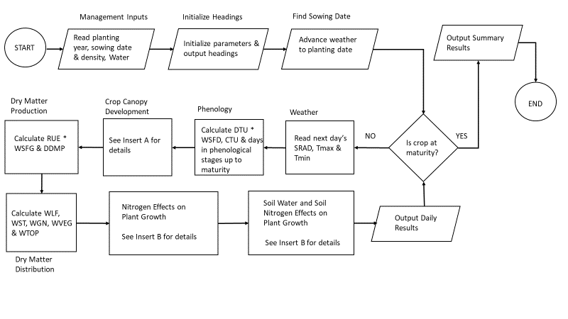

As shown on Insert A, the simulation of nitrogen effects on LAI is performed by the optional CROPLAIN algorithm. This algorithm is preceded by the Phenology module and followed by the Dry Matter Production module.

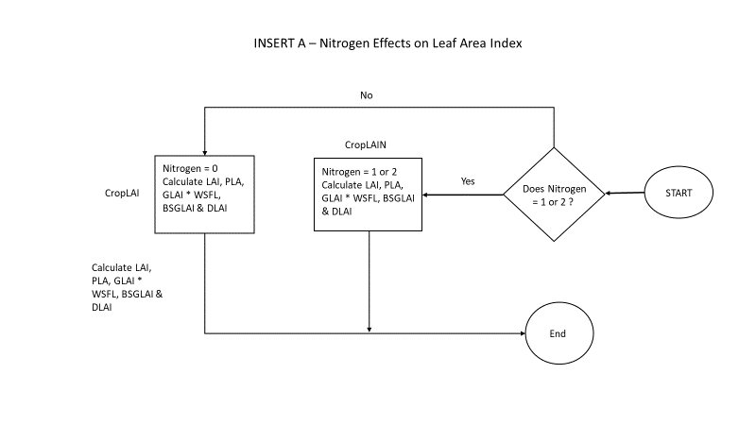

Unlike the **CROPLAI** algorithm which is based solely on accumulated thermal units, the CROPLAIN algorithm includes the additional effects of the transfer of nitrogen to and from the plant leaves on the crop canopy development and senescence.

As shown on the Insert B flowchart, SSLNM allows the simulation of the combined effects of soil water content and nitrogen in the plant and soil water. These modules follow the Dry Matter Distribution module and precede the Output of Daily Results.

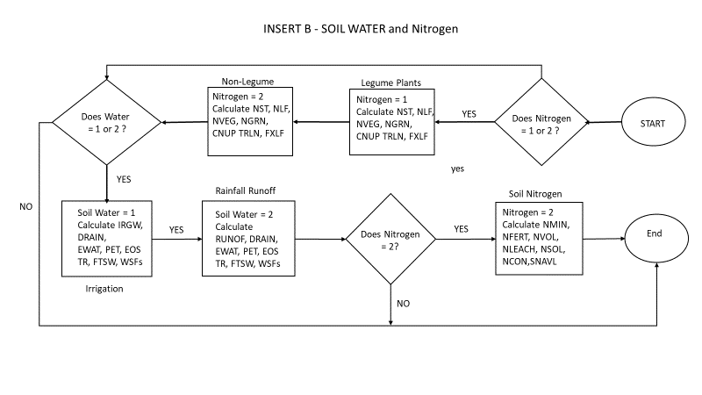

The potential growth model (SSPM) can still be selected by specifying Water = 0 and Nitrogen = 0 in **ManageInputs**. The water limited model (SSWLM) can be selected by specifying Water = 1 (Irrigation) or 2 (Rainfall) and Nitrogen = 0 in **ManageInputs**. The simulation of nitrogen limited conditions is selected by specifying Nitrogen = 1 for legumes and Nitrogen = 2 for non-legumes. The simulation of soil nitrogen effects is only done for non-legumes which have included soil water simulations.

The **Weather**, **Phenology, SoilWater** and **CropLAI** modules remain unchanged from the SSPPM and SSLWM modules described in Chapters 12 and 16 above.

The **CropLAIN** module is mostly similar to the **CROPLAI** module. The algorithm is described below. Variables from other modules are highlighted in yellow and differences with CROPLAI are highlighted in green.

‘………………………Read the following crop parameters from the **CropParameters** file

PHYL # Phyllochron (oC per leaf)

PLACON # Constant multiplier for eqn relating LAI to main stem node number, INODE

PLAPOW # Power coefficient for eqn relating LAI to main stem node number, INODE

SLA # Specific leaf area per gram of leaf mass m2 per grm

‘………………………Initialize variables

MSNN = 1 # Initial node number

PLA2 = 0 # Canopy leaf area today, cm2 per plant

PLA1 = 0 # Canopy leaf area yesterday, cm2 per plant

LAI = 0 # Leaf area index, m2 leaves per m2 ground surface

MXLAI = 0 # Max leaf area, m2 m-2

WSFL = 1 # Water stress factor for leaf development

SLNG = 2 # Target leaf N content (gms N m-2)

'------------------------------- Yesterday LAI to intercept PAR today

If GLAI > (INLF / SLNG) Then GLAI = (INLF / SLNG) # Limit daily increase in LAI (GLAI) to the daily available N for leaf expansion. INLF is daily rate of nitrogen accumulation in leaves computed in ???

LAI = LAI + GLAI – DLAI # Calculate cumulative LAI including senescence (DLAI)

If LAI < 0 Then LAI = 0

If LAI > MXLAI Then MXLAI = LAI # Saving maximum LAI

'------------------------------- Daily increase and decrease in LAI today

If CTU <= tuEMR Then # No Leaf development or senescence before EMR

GLAI = 0 Note – DLAI is not set to 0 here as in the CropLAI module

ElseIf CTU > tuEMR And CTU <= tuTLM Then # Vegetative growth stage

INODE = DTU / PHYL # Daily increase in node number, # day-1

MSNN = MSNN + INODE # Total # of nodes

PLA2 = PLACON * MSNN ^ PLAPOW # Total plant LAI today

GLAI = ((PLA2 - PLA1) * PDEN / 10000) * WSFL # Daily increase in LAI Note – Planting density PDEN is a management parameter. If water stress is simulated WSFL is computed in Soil Water module.

PLA1 = PLA2 # Update yesterday’s plant leaf area

Note – DLAI is not set to 0 here as in the non N LAI model

ElseIf CTU > tuTLM And CTU <= tuBSG Then # Transition stage before BSG

GLAI = GLF * SLA

BSGLAI = LAI # Saving LAI at BSG

ElseIf CTU > tuBSG Then # Beginning of seed growth BSG

GLAI = GLF * SLA # Daily increase in leaf weight, GLF, is calculated in Dry Matter production module

BSGLAI = LAI # Saving LAI at BSG

Note – DLAI is not set to 0 here as in the non N LAI model

ElseIf CTU > tuBSG Then # Grain filling stage

GLAI = 0 # No leaf growth after grain filling

End If

DLAI = XNLF / (SLNG - SLNS) # Leaf senescence based on translocation of N from leaves regardless of growth stage. XNLF is daily rate of nitrogen mobilized from leaves. SLNS is specific leaf nitrogen in senesced leaves.

Return

The simulation of N-limited plant growth is represented in separate modules for non-leguminous plant (**NonLegumePlantN**) and leguminous crop (**LegumePlantN**). The simulation of **non-leguminous crops** is described in this section. Variables from other modules are highlighted in yellow.

‘………………………Read the following crop parameters from the **CropParameters** input file.

SLNG # Specific leaf nitrogen in green leaves (gm N m-2)

SLNS # Specific leaf nitrogen in senesced leaves (gm N m-2)

SNCG # Stem nitrogen concentration in green stems (gm N per gm stem)

SNCS # Stem nitrogen concentration in senesced stems (gm N per gm stem)

GNC # Grain nitrogen concentration (gm N per gm grain)

MXNUP # Maximum uptake (fixation) rate of nitrogen (gm N m-2 per day)

‘………………………Initialize variables

NST = WST * SNCG # Accumulated nitrogen in stems (gm N m-2)

NLF = LAI * SLNG # Accumulated nitrogen in leaves (gm N m-2)

CNUP = NST + NLF # Accumulated nitrogen in above ground crop (gm N m-2)

NGRN = 0 # Accumulated nitrogen in grains (gm N m-2)

If CTU <= tuEMR Or CTU > tuTSG Then **# Pre-emergence Emergence EMR OR Post Grain Filling**

NUP = 0 # Daily rate of nitrogen accumulation in above ground crop (gm N m-2 day-1)

XNLF = 0 # Daily rate of nitrogen mobilized from leaves (gm N m-2 day-1)

XNST = 0 # Daily rate of nitrogen mobilized from stems (gm N m-2 day-1)

NLF = 0 # Accumulated nitrogen in leaves (gm N m-2)

INST = 0 # Daily rate of nitrogen accumulated in stems (gm N m-2 day-1)

INGRN = 0 # Daily rate of nitrogen accumulated in grains (gm N m-2 day-1)

ElseIf CTU > tuEMR And CTU < tuBSG Then **# Vegetative stage**

INGRN = 0 # Daily rate of nitrogen accumulated in grains (gm N m-2 day-1)

NSTDF = (WST * SNCG) – NST # Amount of nitrogen required to bring stem nitrogen to target concentration (gm N m-2)

If NSTDF < 0 Then NSTDF = 0 # There is no N deficit

NUP = (GST * SNCG) + (GLAI * SLNG) '+ NSTDF '<----- Inactive! # Total plant nitrogen demand (

If NUP > MXNUP Then NUP = MXNUP # Limit to crop maximum parameter

If NUP < 0 Then NUP = 0

If FTSW1 > 1 Then NUP = 0 # Layer 1 is saturated

If DDMP = 0 Then NUP = 0 # No dry matter is being produced.

If NUP > SNAVL Then NUP = SNAVL # Limited soil nitrogen available

If NST <= (WST * SNCS) Then # Testing whether accumulated stem N ≤ minimum needed for stems. If true, stems have priority for daily N increase

INST = WST * SNCS – NST # Determine the N deficit and needed daily increase in stem N

XNST = 0 # No decrease in stem N)

If INST >= NUP Then # Is the needed daily increase in stem N greater than NUP?, If true

INLF = 0 # No increase in leaf N

XNLF = INST – NUP # Decrease leaf N which will decrease LAI (senescence))

ElseIf INST < NUP Then # Is needed increase in stem N < NUP

INLF = GLAI * SLNG # Leaf N demand today

If INLF > (NUP - INST) Then INLF = NUP – INST # Is the daily increase in leaf N < NUP, If true, provide the leaves with difference between NUP and the stem deficit

INST = NUP – INLF #Remainder to stems

XNLF = 0 # No decrease in leaf N

End If

ElseIf NST > (WST * SNCS) Then # Is stem N greater than minimum target? If true, leaves have priority for daily increase in leaf N

INLF = GLAI * SLNG # Daily increase in leaf N targeted

XNLF = 0 # No decrease in leaf N

If INLF >= NUP Then # Is daily increase target greater than available N

INST = 0 # No increase in stem N

XNST = INLF – NUP # Decrease stem N by difference between targeted leaf N increase and NUP)

If XNST > (NST - WST * SNCS) Then XNST = NST - WST * SNCS # If XNST > the mobilizable stem N then limit stem N decrease to the mobilizable N

INLF = NUP + XNST # Daily leaf N increase is NUP + transfer of stem N

ElseIf INLF < NUP Then # Daily increase is less than NUP. Therefore, there is some N available to increase the stem N

INST = NUP – INLF # Increase the stem N by the remaining available N

XNST = 0 # No decrease in stem N

End If

End If

ElseIf CTU >= tuBSG And CTU <= tuTSG Then **# Grain filling stage**

INGRN = SGR * GNC # Daily N demand by seeds

NUP = INGRN # Grains are only N sink

# Note - Constraints on NUP in the grain filling stage.

If FTSW1 > 1 Then NUP = 0 # Soil near saturation

If DDMP <= (SGR / GCC) Then NUP = 0 # This constraint says that if the daily dry matter production, DDMP < the seed growth rate (SGR) divided by the grain conversion coefficient (GCC) which accounts for the type of dry matter produced (GCC < 1 for high protein & lipid seeds), then NUP = 0

If DDMP = 0 Then NUP = 0 # No dry matter production

If NUP > SNAVL Then NUP = SNAVL # NUP in excess of available soil N

If NUP > (SGR * GNC) Then # N is in excess of seed needs

INLF = 0 # No increase in leaf N

INST = NUP - SGR * GNC # Increase stem N by difference between NUP and seed growth N

XNLF = 0 # No translocation from leaves

XNST = 0 # No translocation from stem

ElseIf NUP <= (SGR * GNC) Then # Need to transfer N from vegetative tissue

INLF = 0 # No increase in leaf N

INST = 0 # No increase in stem N

XNLF = (SGR * GNC - NUP) * FXLF # Decrease in leaf N

XNST = (SGR * GNC - NUP) * (1 - FXLF) # Decrease in stem N

End If

End If

NST = NST + INST – XNST # Total N in stems

NLF = NLF + INLF – XNLF # Total N in leaves

NVEG = NLF + NST # Total N in above ground plant

NGRN = NGRN + INGRN # Total N in grain

CNUP = CNUP + NUP # Total N in above ground plant organs)

**Note – The total translocatable N in the leaves and stems and the leaf fraction are adjusted during each time step.**

TRLN = LAI * (SLNG - SLNS) + (NST - WST * SNCS) # Total translocatable N in the leaves and stems

FXLF = LAI * (SLNG - SLNS) / (TRLN + 0.000000000001) # Fraction of total N mobilized from leaves

If FXLF > 1 Then FXLF = 1 # Limit fraction to 1

If FXLF < 0 Then FXLF = 0 # Fraction must be positive

Return

The simulation of leguminous crops (**LegumePlantN**) is described in this section. Variables from other modules are highlighted in yellow andcode that differs from **NonLegumePlantN** is highlighted in light green.

‘………………………Read the following crop parameters from the **CropParameters** input file.

SLNG # Specific leaf nitrogen in green leaves (gm N m-2)

SLNS # Specific leaf nitrogen in senesced leaves (gm N m-2)

SNCG # Stem nitrogen concentration in green stems (gm N per gm stem)

SNCS # Stem nitrogen concentration in senesced stems (gm N per gm stem)

GNC # Grain nitrogen concentration (gm N per gm grain)

MXNUP # Maximum uptake (fixation) rate of nitrogen (gm N m-2 per day)

tuBNF # Temperature units for initiation of N2 fixation (oC)

WSSN # Soil water threshold (FTSW) when N fixation starts to decline

INSOL # Initial soil N content (g N m-2)

‘………………………Initialize variables

NST = WST * SNCG # Accumulated nitrogen in stems (gm N m-2)

NLF = LAI * SLNG # Accumulated nitrogen in leaves (gm N m-2)

CNUP = NST + NLF # Accumulated nitrogen in above ground crop (gm N m-2)

NGRN = 0 # Accumulated nitrogen in grains (gm N m-2)

WSFN = 1 # Water stress factor for N fixation

If CTU <= tuEMR Or CTU > tuTSG Then **# Pre-emergence Emergence EMR OR Post Grain Filling**

NUP = 0 # Daily rate of nitrogen accumulation in above ground crop (gm N m-2 day-1)

XNLF = 0 # Daily rate of nitrogen mobilized from leaves (gm N m-2 day-1)

XNST = 0 # Daily rate of nitrogen mobilized from stems (gm N m-2 day-1)

NLF = 0 # Accumulated nitrogen in leaves (gm N m-2)

INST = 0 # Daily rate of nitrogen accumulated in stems (gm N m-2 day-1)

INGRN = 0 # Daily rate of nitrogen accumulated in grains (gm N m-2 day-1)

ElseIf CTU > tuEMR And CTU < tuBSG Then **# Vegetative stage**

INGRN = 0 # Daily rate of nitrogen accumulated in grains (gm N m-2 day-1)

NSTDF = (WST * SNCG) – NST # Amount of nitrogen required to bring stem nitrogen to target concentration (gm N m-2)

If NSTDF < 0 Then NSTDF = 0 # There is no N deficit

NUP = (GST * SNCG) + (GLAI * SLNG) '+ NSTDF '<----- Inactive! # Total plant nitrogen demand

If CTU < tuBNF And CNUP > INSOL Then NUP = 0 # Note – INSOL computed in the **SoilN** module

If NUP > MXNUP Then NUP = MXNUP # Limit to crop maximum parameter

NFC = NFC * 3 / 4 + NUP / WVEG * (1 / 4) # Nitrogen fixation coefficient

NUP = NUP * WSFN # Adjust NUP for high soil water content limiting N fixation

If NUP < 0 Then NUP = 0 # NUP can not be negative

If FTSW > 1 Then NUP = 0 # No N demand when soil is saturated

If DDMP = 0 Then NUP = 0 # No dry matter is being produced.

If NST <= (WST * SNCS) Then # Testing whether accumulated stem N ≤ minimum needed for stems. If true, stems have priority for daily N increase

INST = WST * SNCS – NST # Determine the N deficit and needed daily increase in stem N

XNST = 0 # No decrease in stem N)

If INST >= NUP Then # Is the needed daily increase in stem N greater than NUP?, If true

INLF = 0 # No increase in leaf N

XNLF = INST – NUP # Decrease leaf N which will decrease LAI (senescence))

ElseIf INST < NUP Then # Is needed increase in stem N < NUP

INLF = GLAI * SLNG # Leaf N demand today

If INLF > (NUP - INST) Then INLF = NUP – INST # Is the daily increase in leaf N < NUP, If true, provide the leaves with difference between NUP and the stem deficit

INST = NUP – INLF # Remainder to stems

XNLF = 0 # No decrease in leaf N

End If

ElseIf NST > (WST * SNCS) Then # Is stem N greater than minimum target? If true, leaves have priority for daily increase in leaf N

INLF = GLAI * SLNG # Daily increase in leaf N targeted

XNLF = 0 # No decrease in leaf N

If INLF >= NUP Then # Is daily increase target greater than available N

INST = 0 # No increase in stem N

XNST = INLF – NUP # Decrease stem N by difference between targeted leaf N increase and NUP)

If XNST > (NST - WST * SNCS) Then XNST = NST - WST * SNCS # If XNST > the mobilizable stem N then limit stem N decrease to the mobilizable N

INLF = NUP + XNST # Daily leaf N increase is NUP + transfer of stem N

ElseIf INLF < NUP Then # Daily increase is less than NUP. Therefore, there is some N available to increase the stem N

INST = NUP – INLF # Increase the stem N by the remaining available N

XNST = 0 # No decrease in stem N

End If

End If

ElseIf CTU >= tuBSG And CTU <= tuTSG Then **# Grain filling stage**

INGRN = SGR * GNC # Daily N demand by seeds

NUP = INGRN # Grains are only N sink

PDNF = NFC * WVEG # PDNF is the potential rate of N fixation (g N m-2 day-1) & NFC is the coefficient of biological N fixation per unit vegetative mass.

If PDNF > NUP Then PDNF = NUP # Limits PDNF to NUP

DNF = PDNF * WSFN # DNF is actual rate of N fixation as limited by soil water content

If FTSW > 1 Then DNF = 0 # Similar to NUP constraint in **NonLegumeN** module but uses whole profile fraction of transpirable water (FTSW) instead of just layer 1 (FTSW1).

If DNF < 0 Then DNF = 0 # DNF can not be negative

If DDMP <= (SGR / GCC) Then DNF = 0 # This constraint says that if the daily dry matter production, DDMP < the seed growth rate (SGR) divided by the grain conversion coefficient (GCC) which accounts for the type of dry matter produced (GCC < 1 for high protein & lipid seeds), then DNF = 0

If DDMP = 0 Then DNF = 0 # This constraints similar to NUP constraint in the **NonLegumeN** module

NUP = DNF # Assign NUP the value of DNF

If NUP > (SGR * GNC) Then # N is in excess of seed needs

INLF = 0 # No increase in leaf N

INST = NUP - SGR * GNC # Increase stem N by difference between NUP and seed growth N

XNLF = 0 # No translocation from leaves

XNST = 0 # No translocation from stem

ElseIf NUP <= (SGR * GNC) Then # Need to transfer N from vegetative tissue

INLF = 0 # No increase in leaf N

INST = 0 # No increase in stem N

XNLF = (SGR * GNC - NUP) * FXLF # Decrease in leaf N

XNST = (SGR * GNC - NUP) * (1 - FXLF) # Decrease in stem N

End If

End If

NST = NST + INST – XNST # Total N in stems

NLF = NLF + INLF – XNLF # Total N in leaves

NVEG = NLF + NST # Total N in above ground plant

NGRN = NGRN + SGR * GNC # Total N in grain based on seed grain dry matter & grain nitrogen concentration

CNUP = CNUP + NUP # Total N in above ground plant organs

**Note – The total translocatable N in the leaves and stems and the leaf fraction are adjusted during each time step.**

TRLN = LAI * (SLNG - SLNS) + (NST - WST * SNCS) # Total translocatable N in the leaves and stems

FXLF = LAI * (SLNG - SLNS) / (TRLN + 0.000000000001) # Fraction of total N mobilized from leaves

If FXLF > 1 Then FXLF = 1 # Limit fraction to 1

If FXLF < 0 Then FXLF = 0 # Fraction must be positive

Return

The **SoilN** module requires several additional inputs including the soluble N (NSOL), the initial soil organic N available for mineralization (NORG) as well as the date, amount and volatization fraction (VOLF) for each fertilizer application. NSOL and NORG can be calculated at the beginning of the simulation by specifying some properties of the soil physical and chemical conditions.

‘………………………Read the following crop parameters from the **SoilParameters** input file.

FG # Fraction of soil particles > 2 mm (ND)

BD # Soil bulk density (g cm-3)

NORGP # Soil organic N (%)

FMIN # Fraction of soil organic N available for mineralization (ND)

NO3 # NO3 concentration in soil solution (ppm or mg kg-1)

NH4 # NH4 concentration in soil solution (ppm or mg kg-1)

‘………………………Compute soil nitrogen initial properties

SOILM = DEP1 * BD * (1 – FG) * 1000 # Soil weight in top layer (g soil m-2)

NORG = (0.01 * NORGP) * SOILM # Total organic soil N in top layer (g N m-2)

MNORG = FMIN * NORG # Amount of soil organic nitrogen in top layer (g N m-2)

NO3 = NO3 * (14/62) * 10-6 * SOILM # Amount of N in form NO3 in top layer (g N m-2)

NH4 = NH4 * (14/18) * 10-6 * SOILM # Amount of N in form NH4 in top layer (g N m-2)

NSOL = NO3 + NH4 # Initial soil N (g N m-2 )

NCON = NSOL / (WAT1 * 1000) # Initial soil N concentration (g N g-1 H20)

INSOL = NSOL # Initial soil N concentration

‘………………………Initialize accumulator variables

CNFERT = 0 # Number of fertilizer applications

CNVOL = 0 # Amount of volatilized N

CNLEACH = 0 # Amount of N leached

CNMIN = 0 # Amount of organic N mineralized

CNDNIT = 0 # Amount of denitrified N

'------------------------------- N net mineralization

TMPS = TMP # Average daily TMP is used for soil temperature

If TMPS > 35 Then TMPS = 35 # Limits max soil temp to 35 oC

KNMIN = 24 * Exp(17.753 - 6350.5 / (TMPS + 273)) / 168 # Calculate N mineralization exponent

KN = 1 - Exp(-KNMIN) # Soil temperature coefficient of N mineralization

If FTSW1 < 0.9 Then RN = 1.111 * FTSW1 # Soil moisture coefficient for N mineralization

If FTSW1 >= 0.9 Then RN = 10 - 10 * FTSW1 # Soil moisture coefficient for N mineralization (high moisture)

If RN < 0 Then RN = 0 # RN cannot be negative

NMIN = MNORG * RN * KN # Compute mineralization of organic N (g N m-2 day-1)

NMIN = NMIN * (0.0002 - NCON) / 0.0002 # Threshold = 200 mg N L-1

If NMIN < 0 Then NMIN = 0 # NMIN can not be negative

MNORG = MNORG – NMIN # Reduce available mineralizable organic N by amount mineralized

CNMIN = CNMIN + NMIN # Accumulate mineralized organic N

Next the **N application and volatilization** sub-module code is executed.

**'------------------------------- N application & volatilization**

NFERT = 0 # Initialize amount of N

NVOL = 0: # Initialize volatilization fraction

For N = 1 To FN # No. of fertilizer applications

If DAP = DAPNF(N) Then # Days after planting (DAP) for Nth fertilizer application

NFERT = NFERTI(N) # Amount of N fertilizer applied in gm N m-2 during Nth application

VOLF = VOLFI(N) / 100 # Fraction of fertilizer application volatilized

NVOL = VOLF * NFERT # Amount of volatilized N in g N m-2 during Nth application

End If

Next N

CNFERT = CNFERT + NFERT # Accumulate total fertilizer applied

CNVOL = CNVOL + NVOL # Accumulate total N volatilized

'------------------------------- N downward movement

NLEACH = NSOL * (DRAIN1 / (WAT1 + DRAIN1)) # Amount of soluble N in g N m-2 leached from layer 1

If NCON <= 0.000001 Then NLEACH = 0 # Limit leaching to soluble concentration above threshold of 1 mg N L-1

CNLEACH = CNLEACH + NLEACH # Accumulate total N leached

**'------------------------------- N denitrification**

NDNIT = 0 # Initialize the denitrification

If FTSW1 > 1 Then # Denitrification only occurs when anaerobic conditions (FTSW1 > 1) exist

XNCON = NCON # Initialize temporary variable to soluble N concentration

If XNCON > 0.0004 Then XNCON = 0.0004 # Limit denitrification to threshold = 400 mg N L-1

KDNIT = 6 * Exp(0.07735 * TMPS - 6.593) # Calculate effect of temperature on denitirification

NDNIT = XNCON * (1 - Exp(-KDNIT)) # Calculate denitrification in g N g-1 H2O

NDNIT = NDNIT * WAT1 * 1000 # Convert NDNIT to units of g N m-2

End If

CNDNIT = CNDNIT + NDNIT # Accumulate total denitrification

'------------------------------ Frac. top layer with roots

FROOT1 = DEPORT / DEP1 # Fraction of root zone in layer 1

If FROOT1 > 1 Then FROOT1 = 1 # Fraction cannot be greater than 1

'------------------------------ Updating

NSOL = NSOL + NMIN + NFERT - NVOL - NLEACH - NDNIT – NUP # Previous day plus additions to layer 1 from mineralization (NMIN), fertilizer (NFERT) minus losses from volatilization (NVOL), leaching (NLEACH), denitrification (NDNIT) and crop uptake (NUP). Note NUP computed in the CROPLAIN module (Chapter 17).

NCON = NSOL / (WAT1 * 1000) # Calculate soluble N concentration in soil solution (g N g-1 H20) from soil N (g N m-2) by multiplying by available soil water content in layer 1 (WAT, mm) times conversion factor 1000 g H20/mm m2

SNAVL = (NCON - 0.000001) * ATSW1 * 1000 * FROOT1 # Calculate soil available N (g N m-2) based on threshold = 1 mgN.L-1 (Note conversion factor 1 mg N L-1 = 0.000001 g N / g H20 See above) and 1000 g H20 / mm m2

If SNAVL < 0 Then SNAVL = 0 # Soil soil available N can not be negative

Return